Math 3 8.6 Tangent Lines of Circles Unit 8

*SWBAT solve for unknown variables using theorems about tangent lines of circles.*

|  |  |  |
| --- | --- | --- |
| Tangent to a Circle  Ex: (AB) | A line in the plane of the circle that intersects the circle in exactly one point.  ***Ex:*** *Segment AB is a tangent to Circle O.* |  |
| Point of Tangency | The point where a circle and a tangent intersect.  ***Ex:*** *Point P is a point of tangency on Circle O.* |

|  |  |
| --- | --- |
| **Tangent Theorem 1:** | **Converse Theorem 1:** |
| If a line is tangent to a circle, then it is perpendicular to the radius draw to the point of tangency. | If a line is perpendicular to the radius of a circle at its endpoint on a circle, then the line is tangent to the circle. |



**Example:** If RS is tangent, then PR _____ RS.

**Example 1:** Find the measure of x.

1.  b)

**Example 2:** Find x. *All segments that appear tangent are tangent to Circle O.*

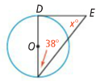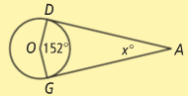a) b)

**Example 3:** Is segment MN tangent to Circle O at P? Explain.

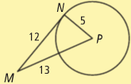

|  |  |
| --- | --- |
| **Tangent Theorem 2:** | *If two tangent segments to a circle share a common endpoint outside the circle, then the two segments are congruent.* |

**Example 4:** Solve for x.

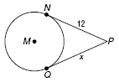 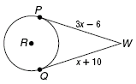 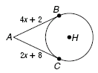

|  |  |  |
| --- | --- | --- |
| Circumscribed vs. Inscribed | |  |
| To***circumscribe***is when you draw a figure around another, touching it at points as possible. | To ***inscribe*** is to draw a figure within another so that the inner figure lies entirely within the boundary of the outer. |
| ***Ex:*** *The circle is circumscribed about the triangle.* | ***Ex:*** *The triangle is inscribed in the circle.* |

|  |  |
| --- | --- |
| **Tangent Theorem 3:**  **(Circumscribed Polygons)** | *When a polygon is circumscribed about a circle, all of the sides of the polygon are tangent to the circle.* |

 

**Example 5:** Triangle ABC is circumscribed about $⊙$ O. Find the perimeter of triangle ABC.



**You Try!** Find x. Assume that segments that appear to be tangent are tangent.



1. b b) c)