Math 1 8.6 Graphing Intercept Form Unit 8
SWBAT graph a quadratic function in intercept form.

y = ____________

Roots = Axis of Symmetry: y-intercept:

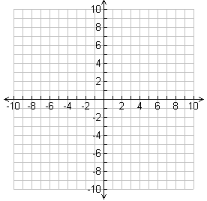

x | y

Example 1: Graph f(x) = 2(x – 4)(x – 6)

Opens: ___________________

Roots: ____________________

Vertex: ___________________

AOS: _____________________

Y-Int: _____________________
x | y

Example 2: Graph f(x) = – (x + 1)(x – 5)

Opens: ___________________

Roots: ____________________

Vertex: ___________________

AOS: _____________________

Y-Int: _____________________

Practice: Sketch the following graphs and list any important information about them.
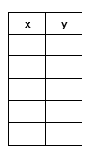

- Graph f(x) = – (x + 2)(x – 4)

Opens: ___________________

Roots: ____________________

Vertex: ___________________

AOS: _____________________

Y-Int: _____________________

- Graph f(x) =2 (x + 3)(x – 1)

Opens: ___________________

Roots: ____________________

Vertex: ___________________

AOS: _____________________

Y-Int: _____________________

- Graph f(x) = – (x +4)(x – 2)

Opens: ___________________

Roots: ____________________

Vertex: ___________________

AOS: _____________________

Y-Int: _____________________

- Graph f(x) = – ½ (x + 2)(x – 4)

Opens: ___________________

Roots: ____________________

Vertex: ___________________

AOS: _____________________

Y-Int: _____________________

