Math 3 8.6 Area of a Sector Unit 8
SWBAT find the arc length of a circle given a central angle in radians or degrees.

Area of a circle: The product of π and the square of the radius.

Example 1: What is the area of the circular region on the wrestling mat?
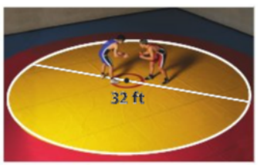

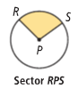

Sector of a Circle: The region bound by an arc of the circle and the two radii that meet at the endpoints of the arc. It is named by using one endpoint, the center of the circle, and the other endpoint.

Area of a Sector (Radians): Area of a Sector (Degrees):

Example 2: Find the area of the sector with the given circle below. Give an exact and a rounded answer.
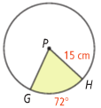

Example 3: The area of sector AOB in the following image is 28π cm². Find the measurement of the central angle labeled x˚.
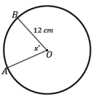

Example 4: Circle O has a minor arc $\hat{AB}$ with an angle measure of 60˚. Sector AOB has an area of 24π. What is the radius of Circle O?

Classwork: Area of a Sector & Arc Length
Math 3
