Math 1 **8.5 Vertex Form of a Quadratic** Unit 8

*SWBAT graph a quadratic equation in vertex form.*

Where (h, k) is the vertex

Vertex Form:

**Example 1:** State the vertex of the following functions.

1. 
2. 
3. 
4. 

**Example 2:** Write the equation in vertex form with the given information.

1. Vertex: (-6, 5); a = 12
2. Vertex: (4, -2); a = -3
3. Vertex: (-3, -8); a = 1
4. Vertex: (7, 2); a = .06
5. Vertex: (0, -8); a = 12
6. Vertex: (-6, 0); a = -9

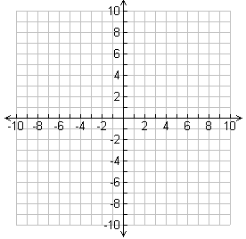

|  |  |
| --- | --- |
| **x** | **y** |
|  |  |
|  |  |
|  |  |
|  |  |
|  |  |

**Example 3:** Graph each of the following.

1. y = 1/2(x – 6)2 – 3

Opens: _________________

AOS: ___________________

Vertex: _________________

Y-Int: ___________________



|  |  |
| --- | --- |
| **x** | **y** |
|  |  |
|  |  |
|  |  |
|  |  |
|  |  |

1. y = – 3(x + 4)2 + 7

Opens: _________________

AOS: ___________________

Vertex: _________________

Y-Int: ___________________

**EOC Practice:** Complete the following EOC-type questions for class credit.

