Math 3 8.5 Similar Polygons Unit 8
SWBAT prove similarity between geometric figures.

Similar Figures: figures that have the same shape but not necessarily the same size. _________ is the symbol.

Similar Polygons | Two polygons are similar polygons if corresponding angles are congruent and if the lengths of the corresponding sides are proportional. | 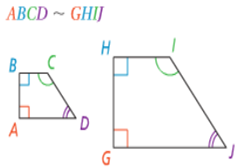 | 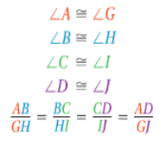
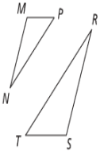
Example 1: ∆MNP ~ ∆SRT
- What are the pairs of congruent angles?

- Write the proportion for the ratios of the corresponding sides.

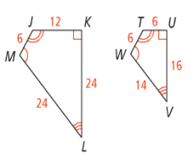
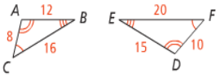
Example 2: Determining whether the polygons are similar. If they are, write a similarity statement and give the scale factor.

- JKLM and TUVW
- ∆ABC and ∆EFD

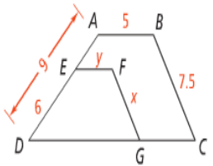
Example 3: ABCD ~ EFGD.

- What is the value of x?
- What is the value of y?

Math 3 8.5 Proving Triangles Similar Unit 8
SWBAT prove similarity between triangles using a two-column proof.

AA $∼$ | SAS $∼$ | SSS$∼$
If two angles of one triangle are congruent to two angles of another triangle, then the triangles are similar. | If an angle of one triangle is congruent to an angle of a second triangle, and the sides that include the two angels are proportional, then the triangles are similar. | If the corresponding sides of two triangles are proportional, then the triangles are similar.

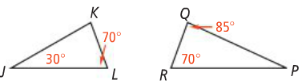
Example 4: Are the two triangles similar? How do you know?

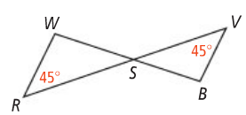

Example 5: Are the two triangles similar? If so, write a similarity statement.

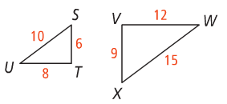
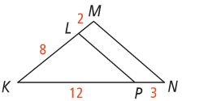

Example 6: Given: $\overline{FG}≅\overline{GH}, \overline{JK}≅\overline{KL}, ∡F≅∡J$
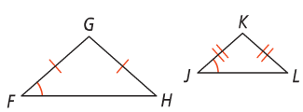
Prove: ∆FGH ~ ∆JKL

Statement | Reason

Example 7: Before rock climbing, Darius wants to know how high he will climb. He places a mirror on the ground and walks backward until he can see the top of the cliff in the mirror. What is the height of the cliff?

