Math 3 8.5 Arc Length of a Circle Unit 8
SWBAT find the arc length of a circle given a central angle in radians or degrees.

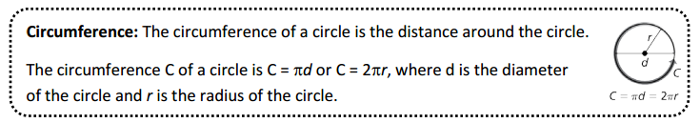
- The radius of a circle is 11 inches. Find the circumference of the circle and round to the nearest hundredth.

- The diameter of a circle is 4 meters. Find the circumference of the circle and round to the nearest hundredth.

- The circumference of a circle is 6 meters. Find the radius of the circle and round to the nearest hundredth.

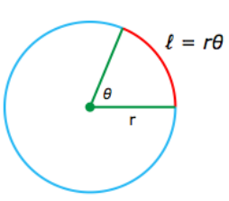
Arc Length (in radians): The formula for arc length in radians is , where is the arc
length, r is the radius, and 𝜃 is the measure of the angle subtended by the arc, in radians.

- The radius of a circle is 1. What is the length of an arc that subtends an angle of 𝜋/3 radians?
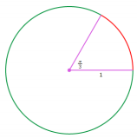

- The radius of a circle is 13 meters. What is the length of an arc that subtends an angle of 𝜋/5 radians?
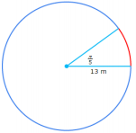

- The radius of a circle is 17 miles. What is the length of an arc that subtends an angle of π radians?
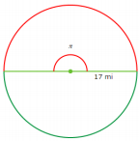

Arc Length (in degrees): Convert the degrees to radians, and then use the radian
formula! Remember, to convert degrees to radians, multiply by:

- Find each indicated measure. If necessary, round to the nearest tenth.
