Math 1 8.4 Graphing Standard Form of a Quadratic Unit 8
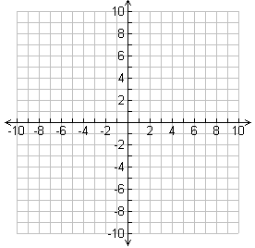
Graph
y = x² – 2x – 3

Standard Form: y =

Important Vocabulary

Y-Intercept: _____________________________________________________________________________________
AOS Formula
X-Intercept (root, zero, solution): ___________________________________________________
Vertex: ____________________________________________________________________________
Axis of Symmetry: __________________________________________________________________
“a” Value: _______________________________________________________________________________________
Vertex and Axis of Symmetry
Step 1: Solve for the Axis of Symmetry using the AOS Formula
Step 2: Substitute AOS into the equation for x.
Step 3: Solve for y.
Step 4: Write the vertex as an ordered pair (x, y)

Example 1: Find the vertex and the axis of symmetry for each function.

- y = -2x² + 4x – 9
- y = x² – 10
- y = x² + 4x – 1

Graphing Standard Form

Example 2: Sketch the graph of y = x² – 1 a = ________ b = ________ c = ________

x | y
Opens: _________________

AOS: ___________________

Vertex: _________________

Y-Int: ___________________

Roots: __________________

Example 3: Sketch the graph of y = x² – 1 a = ________ b = ________ c = ________
x | y
Opens: _________________

AOS: ___________________

Vertex: _________________

Y-Int: ___________________

Roots: __________________

