Math 3 8.4 Quadrilaterals Unit 8
SWBAT use the properties of quadrilaterals to solve for unknowns.

Rectangle | Rhombus | Square
A rectangle is a parallelogram with four right angles. | A rhombus is a parallelogram with four congruent sides. | A square is a parallelogram with four congruent sides and four right angles.
A rectangle has all the properties of a parallelogram PLUS:  - 4 right angles  - Diagonals are congruent  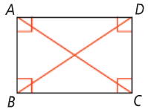 | A rhombus has all the properties of a parallelogram PLUS:  - 4 congruent sides  - Diagonals bisect angles  - Diagonals are perpendicular  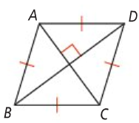 | A square has all the properties of a parallelogram PLUS:  - All the properties of a rectangle  - All the properties of a rhombus  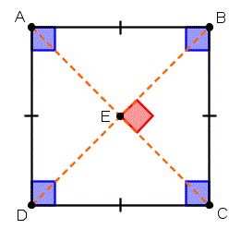

Example 1: Solve for x and the measure of each angle if ▭DGFE is a rectangle.
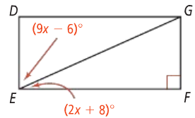

Example 2: ▭ABCD is a rectangle whose diagonals intersect at point E.

- If AE = 36 and CE = 2x – 4, find x.

- If BE = 6y + 2 and CE = 4y + 6, find y.

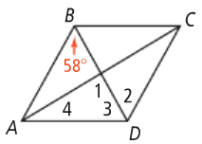
Example 3: Using the diagram to the right to answer the following if ▭ABCD is a rhombus.
- Find the m∠1.
- Find the m∠2.

- Find the m∠3.
- Find the m∠4.

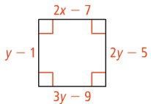
Example 4: Solve for each variable if the following are rhombi.

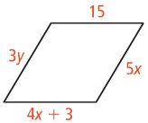

Trapezoid | A trapezoid is a quadrilateral with exactly one pair of parallel sides, called bases, and two nonparallel sides, called legs. | Isosceles Trapezoids | Trapezoid Midsegment
 |  | An isosceles trapezoid is a trapezoid with congruent legs. | The median (also called the midsegment) of a trapezoid is a segment that connects the midpoint of one leg to the midpoint of the other leg.
 |  | A trapezoid is isosceles if there is only:  - One set of parallel sides  - Base angles are congruent  - Legs are congruent  - Diagonals are congruent  - Opposite angles are supplementary | Theorem: If a quadrilateral is a trapezoid, then a) the midsegment is parallel to the bases and b) the length of the midsegment is half the sum of the lengths of the bases
 |  | 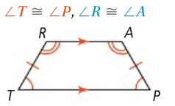 | 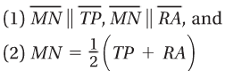  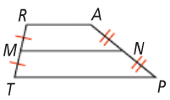

Example 5: CDEP is an isosceles trapezoid and m<C = 65. What are m<D, m<E, and m<F?
Example 6: What are the values of x and y in the isosceles triangle below if DE || DC?

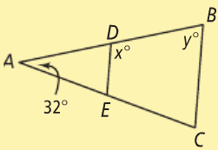
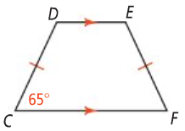

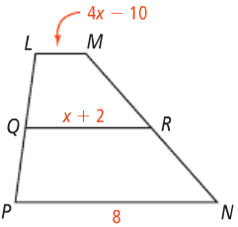
Example 7: QR is the midsegment of trapezoid LMNP. What is x and the length of LM?
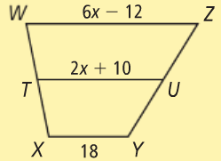
You Try! TU is the midsegment of trapezoid WXYZ. What is x and the length of TU?

Kite | A kite is a quadrilateral with two pairs of adjacent, congruent sides. | If a quadrilateral is a kite, then:
 |  | Its diagonals are perpendicular. | Its diagonals bisect the opposite angles. | One pair of opposite angles are congruent. | One diagonal bisects the other.
 |  | 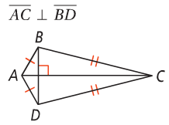 | 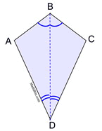 | 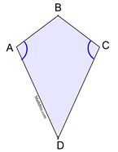 | 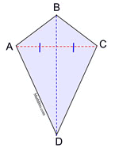

Example 4: Quadrilateral DEFG is a kite. What are m<1, m<2, and m<3?
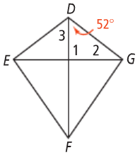

You Try! Quadrilateral KLMN is a kite. What are m<1, m<2, and m<3?

