Math 3 8.4 Angle Measures and Segment Lengths Unit 8
SWBAT apply the rules and theorems of segments to solve for unknowns.

Theorem 1: | Theorem 2:
The measure of an angle formed by two lines that intersect inside a circle is half the sum of the measures of the intercepted arcs. | The measure of an angle formed by two lines that intersect outside a circle is half the difference of the measures of the intercepted arcs.
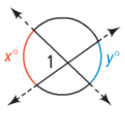  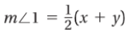 | 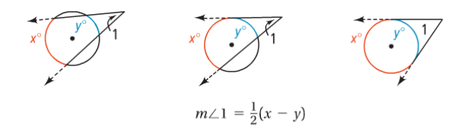

Example 1: Find each measure.
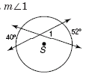
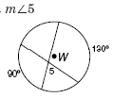
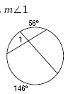

Example 2: Find the following angles.
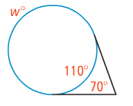

- m∠MPN
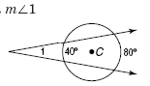

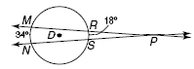

You Try! Find the following angles.
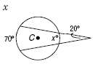

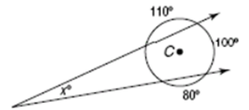
- x
- Arc AB

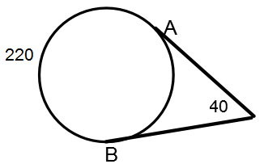

Theorem 3:
For a given point and circle, the product of the lengths of the two segments from the point to the circle is constant along any line through the point and the circle.
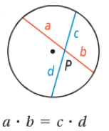 | 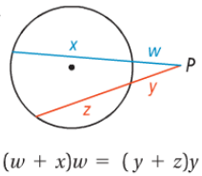 | 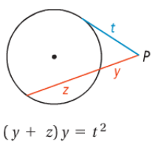

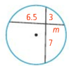
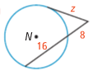
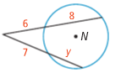
Example 4: Find the value of the variable in $⊙O.$

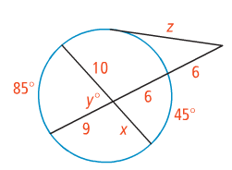
You Try! What is the value of the variable to the nearest tenth?

