Math 3 8.3 Parallelograms Unit 8
SWBAT prove a figure to be a parallelogram and solve for variables in a parallelogram.

Properties of Parallelograms
Sides | A parallelogram is a quadrilateral with both pairs of opposite sides parallel. | 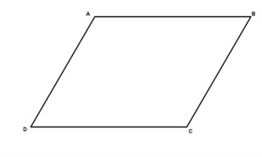
If a quadrilateral is a parallelogram,
the 2 pairs of opposite sides are congruent.
Angles | If a quadrilateral is a parallelogram,  the 2 pairs of opposite angles are congruent.
If a quadrilateral is a parallelogram,
the consecutive angles are supplementary.
If a quadrilateral is a parallelogram and one angle is a right angle,
then all angles are right angles.
Diagonals | If a quadrilateral is a parallelogram,  the diagonals bisect each other.
If a quadrilateral is a parallelogram,
the diagonals form two congruent triangles.

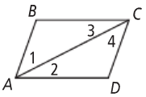
Example 1: Given: ▭ABCD is a parallelogram.
Prove: AB = CD and BC = DA.

Statement | Reason
- ABCD is a parallelogram | 1.
2. | 2. Definition of a parallelogram
- <1 = <4, <3 = <2 | 3.
4. AC = AC | 4.
5. ∆ABC = ∆CDA | 5.
6. | 6. CPCTC
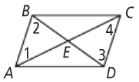
Example 2: Given: ▭ABCD is a parallelogram.
Prove: AC and BD bisect each other at E.

Statement | Reason
1. ABCD is a parallelogram | 1. Given
2. AB || DC | 2.
3. <1 = <4, <2 = <3 | 3.
4. AB = DC | 4.
5. | 5. ASA
6. AE = CE, BE = DE | 6.
7. | 7. Definition of bisector

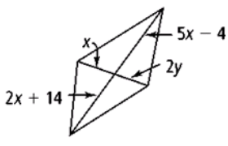
Example 3: For what values of x and y must each figure be a parallelogram?
