Math 3 8.2 Proofs (Parallel Lines and Triangles) Unit 8
SWBAT prove lines to be parallel and prove triangles to be congruent.

What can we use to Prove?
Definition of Vertical Angles | Linear Pair Postulate | Definition of Midpoint
Definition of Supplementary Angles | Corresponding Angle Postulate | Definition of Bisect
Definition of Parallel Lines | Alternate Exterior Angle Theorem | Substitution Property
Definition of Perpendicular Lines | Alternate Interior Angle Theorem | Angle Addition Postulate
Reflexive Property  (AB = AB) | Transitive Property  (a = b, b = c, then a = c) | Segment Addition Postulate
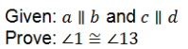
Example 1:

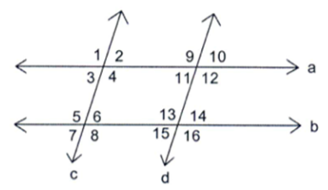
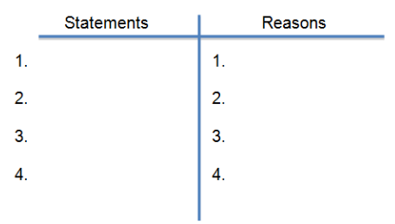

Triangle Congruence
Name: | Picture | Definition | The Donkey Theorem:  You can’t travel (AAA) by Donkey (SSA) to triangle congruence!
Angle-Side-Angle
(ASA)
Side-Angle-Side
(SAS)
Side-Side-Side
(SSS)
Angle-Angle-Side
(AAS)
Hypotenuse-Leg
(HL)
Example 2: Given: J is the midpoint of IL.
J is the midpoint of HK.
Prove: ∆IJH $≅$ ∆LJK

Statement: | Reason:

You Try! Given: WX $∥$ YZ, WX $≅$ YZ
Prove: ∆WXZ $≅$ ∆YZX
(Hint: It should take anywhere from 4-5 steps)
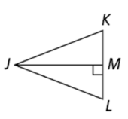
Statement: | Reason:
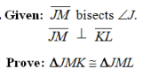
You Try!

Statement: | Reason:

