Math 3 8.2 Chords & Arcs of Circles Unit 8
SWBAT solve for unknown variables using theorems about chords and arcs of circles.
The given point is called the _____________.
This point names the circle.
Any segment with _________________ that are the center and a point on the circle is a _______________.
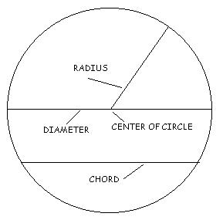

Any segment with ____________________ that are on a circle is called a _______________.

A _____________ that passes through the center is a ______________ of a circle.

Example 1: Name the circle, a radius, a chord, and a diameter of the circle.
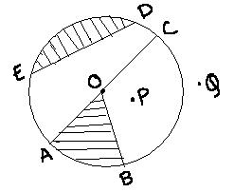
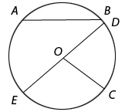
Circle: ___________ Circle: ___________
Radius: ___________ Radius: ___________
Chord: ____________ Chord: ____________
Diameter: __________ Diameter: __________

Since a _________________ is composed of two radii, then d = 2r and r = d/2
Theorem 1: | Converse Theorem 1: | 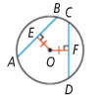
Within a circle or in congruent circles, chords equidistant from the center or centers are congruent. | Within a circle or in congruent circles, congruent chords are equidistant from the center (or centers).
Theorem 2: | Converse Theorem 2: | 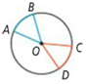
Within a circle or in congruent circles, congruent central angles have congruent arcs. | Within a circle or in congruent circles, congruent arcs have congruent central angles.
Theorem 3: | Converse Theorem 3:
Within a circle or in congruent circles, congruent central angles have congruent chords. | Within a circle or in congruent circles, congruent chords have congruent central angles.
Theorem 4: | Converse Theorem 4: | 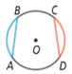
Within a circle or in congruent circles, congruent chords have congruent arcs. | Within a circle or in congruent circles, congruent arcs have congruent chords.
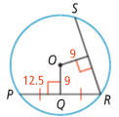
Example 2: The following chords are equidistant from the center of the circle.

a) What is the length of RS?
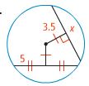
b) Solve for x.

Theorem 5: | 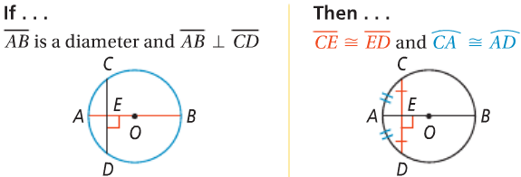
In a circle, if a diameter is perpendicular to a chord, then it bisects the chord and its arc.
Theorem 6: | 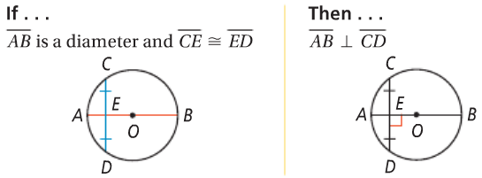
In a circle, if a diameter bisects a chord that is not a diameter, then it is perpendicular to the chord.
Theorem 7: | 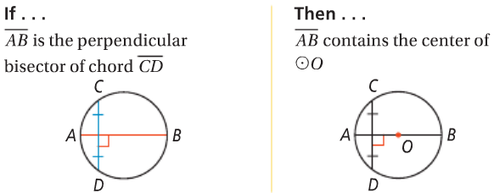
In a circle, the perpendicular bisector of a chord contains the center of the circle.

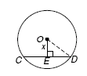
Example 3: In $⊙$O, $\overline{CD}⊥\overline{OE}, OD=15, and CD=24.$Find x.
Example 4: Find the value of x to the nearest tenth.

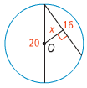

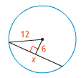
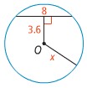
You Try! Find the value of x to the nearest tenth.

