Math 3 8.1 Intro to Geometric Properties Unit 8

*SWBAT examine the properties of lines and angles.*

**Directions:** Match each of the following pictures with the vocabulary listed below.

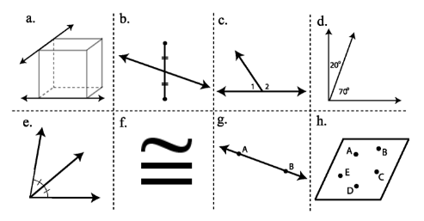

1. ______ Line AB
2. ______ Linear Pair Angles
3. ______ Coplanar points
4. ______ Congruent

(Symbol)

1. ______ Skew lines
2. ______ Complementary

1. ______ Segment bisector
2. ______Angle bisector

Angles

|  |  |  |
| --- | --- | --- |
| Important Vocabulary | | Picture |
| Vertical Angles: |  |  |
| Corresponding Angles: |  |
| Alternate Interior Angles: |  |
| Alternate Exterior Angles: |  |
| Linear Pair: |  |
| Consecutive Interior Angles: |  |
| Consecutive Exterior Angles: |  |

**Directions:** Draw and label three types of triangles classified by angles.

|  |  |  |  |
| --- | --- | --- | --- |
| Name: |  |  |  |
| Picture: |  |  |  |
| Definition: |  |  |  |

**Directions:** Draw and label three types of triangles classified by sides.

|  |  |  |  |
| --- | --- | --- | --- |
| Name: |  |  |  |
| Picture: |  |  |  |
| Definition: |  |  |  |

