Math 3 8.10 Equations of Circles Unit 8

*SWBAT graph circles on the coordinate plane and write the equations of circles in standard form.*

Standard Form of Circles

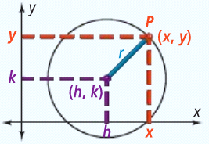

Radius:

Center:

Point on the circle:

**Example 1:** Write the equation of a circle with the given information.

1. Center (0,0), Radius=10

h = k = r =

1. Center (2, 3), Diameter=12

h = k = r =

**Example 2:** Determine the center and radius of a circle the given equation.

1. 
2. 
3. 

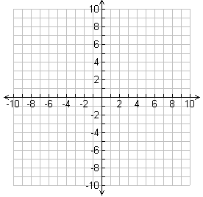**Example 3:** Use the center and the radius to graph each circle.

1. 
2. 

Center:

Radius:

Center:

Radius:

|  |
| --- |
| Writing an Equation with a  Pass-Thru Point |
| ***Step 1:*** Substitute the center (h, k) into the equation |
| ***Step 2:*** Substitute the “pass through point (x, y)”  into the equation for x and y. |
| ***Step 3:*** Simplify and solve for r2. |
| ***Step 4:*** Substitute r2 back into the equation  from Step 1. |

**Example 4:** Write the equation of a circle with a given center (2, 5) that passes through the point (5 ,-1).

|  |  |
| --- | --- |
| Writing an Equation with Two Points  on the Circle | Midpoint Formula |
| Find the midpoint (radius) between the two endpoints, and then follow steps 1-4. |  |
|  |

**Example 5:** Write the equation of a circle with endpoints of diameter at (-6, 5) and (4, -3).

|  |  |
| --- | --- |
| Writing the Equation of a Circle in Standard Form | |
| ***Step 1:*** | Group x’s and group y’s together. |
| ***Step 2:*** | Move any constants to the right side of the equation. |
| ***Step 3:*** | Use complete the square to make a perfect square trinomial for the x’s and then again for the y’s.  *\*Remember, whatever you do to one side of the equation, you must do to the other!* |
| ***Step 4:*** | Simplify factors into standard form of a circle! |

**Example 5:** Write the equation of a circle in standard form. Then, state the center and the radius.

1. x2 + y2 + 4x - 8y + 16 = 0
2. x2 + y2 + 6x - 4y = 0
3. x2 + y2 - 6x - 2y + 4 = 0
4. x2 + y2 + 8x - 10y - 4 = 0