Math 3 7.9 Translating Sine and Cosine Functions Unit 7

*SWBAT translate sine and cosine functions on the coordinate plane.*

  

|  |  |
| --- | --- |
| Horizontal Translation | Vertical Translation |
| h = phase shift (movement left or right) | k = vertical shift (movement up or down) |
|  |  |

**Example 1:** Describe the transformations.

1. 
2. 
3. 

**Example 2:** Write the equation with the given translations.

1. y=sinθ; 3 units right, 2 units down
2. y=cosθ; reflection over x-axis, π units down
3. y=tanθ; compression by ¼, left 5, down 2π

**Graphing Vertical Translations**

|  |  |  |  |  |
| --- | --- | --- | --- | --- |
| ***Step 1:*** | ***Step 2:*** | ***Step 3:*** | ***Step 4:*** | ***Step 5:*** |
| Label what you know (a, b, period) and state the translation | Set up your five key points | Multiply your y-values by “a” | Add or subtract the value of “k” to the new y-value | Plot your points! |

**Example 3:** Graph one cycle of the function

a = b = period = V. Translation:

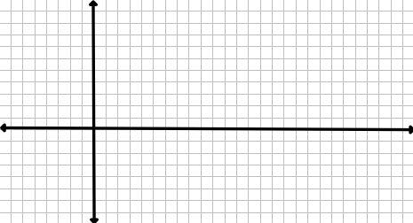

**Graphing Horizontal Translations**

|  |  |  |  |  |
| --- | --- | --- | --- | --- |
| ***Step 1:*** | ***Step 2:*** | ***Step 3:*** | ***Step 4:*** | ***Step 5:*** |
| Label what you know (a, b, period) and state the translation | Set up your five key points | Multiply your θ-values by the reciprocal of b | Add or subtract the value of “h” to the new θ-values | Plot your points! |

**Example 4:** Graph one cycle of the function 

a = b = period = H. Translation:

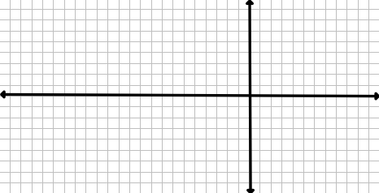

**Putting them Together**

**Example 5:** Graph one cycle of the function 

a = b = period = H. Translation: V. Translation:



