Math 3 7.9 Applications of Trigonometry (Part 1) Unit 7

*EQ: How can you analyze real-life situations to create trigonometric functions and graph them on the coordinate plane?*

|  |
| --- |
|  |

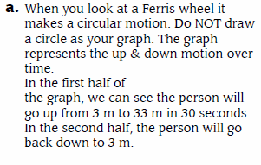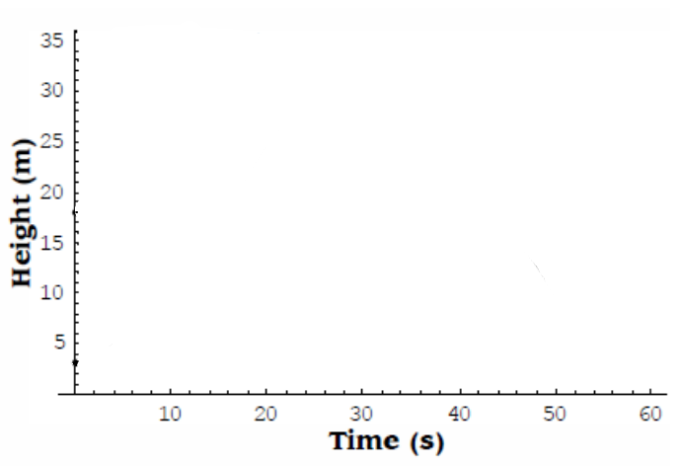

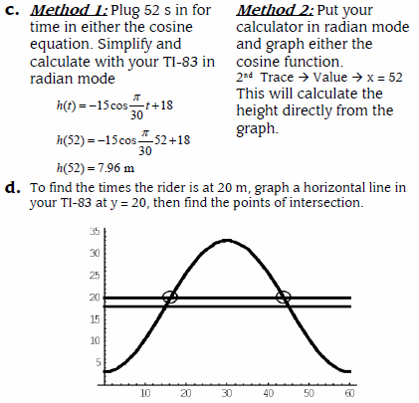







Equation of the Ferris Wheel:

