Math 3 7.8 Translating Sine and Cosine Functions Unit 7

*EQ: How do you translate sine and cosine functions on the coordinate plane?*

 

***Midline:*** The horizontal line (y =) that cuts a sine or cosine graph in half.

|  |  |
| --- | --- |
| Horizontal Translation | Vertical Translation |
| h = phase shift (movement left or right) | k = vertical shift (movement up or down) |
|  |  |

**Example 1:** Describe the transformations.

1. 
2. 
3. 

**Example 2:** Write the equation with the given translations.

1. y=sinθ; 3 units right, 2 units down
2. y=cosθ; reflection over x-axis, π units down
3. y=tanθ; compression by ¼, left 5, down 2π

**Example 3:** Graph one cycle of the following equations.

1. 



1. 

**Example 4:** Use the graph below to answer the following.



1. Write one potential sine function for the graph above.
2. Write one potential cosine function for the graph above.

**Example 5:** The depth of the water at a generating station can be represented with the following graph:

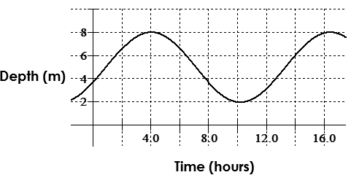

1. Find a possible equation for the graph.
2. Calculate the depth of the water at 9:30 AM.
3. Calculate the depth of the water at 2:52 PM.
4. At what time does the depth of the water first reach 4.3 m?