Math 3 7.8 The Cosine Function Unit 7

*SWBAT graph cosine functions on the coordinate plane by referencing the Unit Circle.*

|  |  |  |
| --- | --- | --- |
| The Cosine Function | Important Vocabulary | Graphing Information |
| $$y=acosbθ$$ | ***Amplitude:*** *Half the difference of the maximum and minimum values of the graph* | ***The Five Key Points:***  *Five main points (in radians) on the Unit Circle* |
|  | ***Cycle:*** *One complete pattern in a graph* | ***To find the values on the x-axis:***  *Start with 5 key points from the Unit Circle and multiply each by the reciprocal of b* |
| ***Period:*** *How long it takes to complete a cycle before the pattern repeats itself* | ***To find the values on the y-axis:***  *Look at the cosine values of your five key points and multiply by ________* |

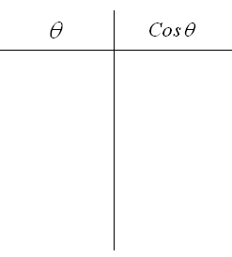

**Example 1:** Sketch one cycle of the equation

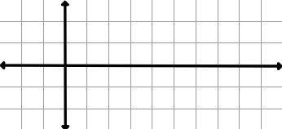

**a = b = Period:**

**Example 2:** Sketch one cycle of the equation



**a = b = Period:** 

**You Try!** Sketch one cycle of the equation

**a = b = Period:**

**Example 3:** Write the function and sketch one cycle of the curve of the cosine function with the following description:

*Amplitude of*  *where a>1 and period of* 3

**a = Period:**

**Cycle:**

**Function Equation:**

**Example 4:** Write the function and sketch one cycle of the curve of the cosine function with the following description:

*Amplitude of 2 where a<1 and period of* 



**a = Period:**

**Cycle:**

**Function Equation:**

**You Try!** Write the function and sketch one cycle of the curve of the cosine function with the following description:

*Amplitude of 0.5 where a<1 and period of 8*



**a = Period:**

**Cycle:**

**Function Equation:**