Math 3 7.7 Graphing Sine and Cosine Functions Unit 7

*EQ: How can you graph co/sine functions on the coordinate plane?*

|  |  |  |
| --- | --- | --- |
| The Sine Function | Important Vocabulary | The Cosine Function |
| $$y=asinbθ$$ | ***Amplitude:*** *Half the difference of the maximum and minimum values of the graph* | $$y=acosbθ$$ |
|  | ***Cycle:*** *One complete pattern in a graph* |  |
| ***Period:*** *How long it takes to complete a cycle before the pattern repeats itself* |

**Example 1:** Sketch one cycle of the equation

**Example 2:** Sketch one cycle of the equation

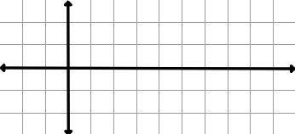

**a = b = Period:**

**a = b = Period:**

**You Try!** Sketch one cycle of the equation

**You Try!** Sketch one cycle of the equation



**a = b = Period:**

**a = b = Period:**

**Example 3:** Write the function and sketch one cycle of the curve of the sine function with the following description:

*Amplitude of 2 where a>0 and period of* 

**a =**

**Period:**

**Cycle (b):**

**Function Equation:**

**Example 4:** Write the function and sketch one cycle of the curve of the cosine function with the following description:

*Amplitude of 4 where a<0 and period of* 



**a =**

**Period:**

**Cycle (b):**

**Function Equation:**

**You Try!** Write the function and sketch one cycle of the curve of the cosine function with the following description:

*Amplitude of 5 where a<0 and period of* 2



**a =**

**Period:**

**Cycle (b):**

**Function Equation:**