Math 3 7.6 Exploring Periodic Data Unit 7
Identifying Cycles and Periods of a Function
- A periodic function is a function that repeats a pattern of ________________ (or outputs) at regular intervals.
- One complete pattern is a _________________. A cycle may begin at any point on the graph of a function.
- The period of a function is the horizontal length of one cycle. Periodic behavior is behavior that repeats over intervals of _____________________.

Example 1: Analyze the periodic function below. Identify the cycle in two different ways. What is the period of this function?

Identifying Periodic Functions
To determine if a function is periodic, analyze the functions graph to see if the y-values (or outputs) of the graph repeat.

Example 2: Is the function periodic? If it is, what is its period?
You Try! Is the function periodic? If is it, what is its period?

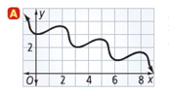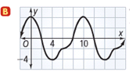

Midline: The line (y = ) that cuts the function in half horizontally.
Amplitude: The amplitude of a periodic function measures the amount of variation from the midline in the function values. The amplitude can be found by finding the _____________________between the maximum and minimum value and dividing it by 2.

Midline = ________________________ Amplitude= ________________________

Example 3: What is the amplitude and midline of the periodic functions below?
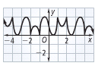
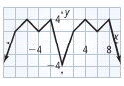

 | The Sine Function | The Cosine Function
Equation | $$y=asinbθ$$ | $$y=acosbθ$$
Graph | 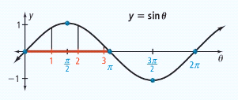 | 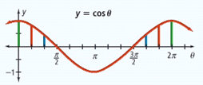
Key Ideas
______ is the amplitude of the function
______ is the number of cycles in the interval from _____________

b = ___________
Period = ___________

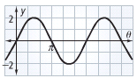
Example 4: Find the period of the sine curve. Then write an equation for the function.

Period = Amplitude = a = b =

Equation:

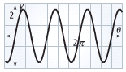
You Try! Find the period of the sine curve. Then write an equation for the function.

Period = Amplitude = a = b =

Equation:

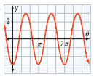
Example 5: Find the period of the cosine curve. Then write an equation for the function.

Period = Amplitude = a = b =

Equation:

