Math 3 7.5 The Unit Circle Unit 7
EQ: How can you create a unit circle and evaluate trigonometric values from the unit circle?

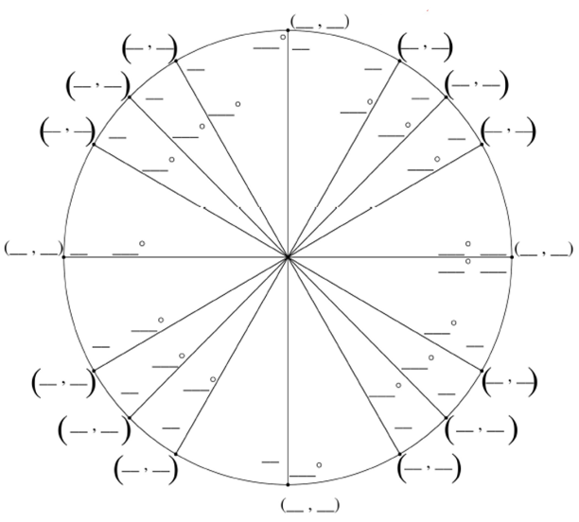

Each ordered pair is represented by
(x, y) = (Cosine, Sine)

Trigonometric Identities: | $$\sin{θ=y}$$ | $$\cos{θ}=x$$ | $$\tan{θ}=\frac{sinθ}{cosθ}=\frac{y}{x}$$
Reciprocal Identities: | $$\csc{θ=\frac{1}{sin θ}=\frac{1}{y}}$$ | $$\sec{θ}=\frac{1}{cos θ}=\frac{1}{x}$$ | $$\cot{θ}=\frac{cosθ}{sinθ}=\frac{x}{y}$$
Example 1: Evaluate the six trigonometric functions for $θ=\frac{π}{6}$

Sine $θ=$
Cosecant $θ=$

Cosine $θ=$
Secant $θ=$

Tangent $θ=$
Cotangent $θ=$

Example 2: Evaluate the six trigonometric functions for $θ=225°$

Sine $θ=$
Cosecant $θ=$

Cosine $θ=$
Secant $θ=$

Tangent $θ=$
Cotangent $θ=$

Example 3: Evaluate the six trigonometric functions for $θ=-540°$

Sine $θ=$
Cosecant $θ=$

Cosine $θ=$
Secant $θ=$

Tangent $θ=$
Cotangent $θ=$

Example 4: Find the six trigonometric functions for $θ=-\frac{π}{2}$

Sine $θ=$
Cosecant $θ=$

Cosine $θ=$

Secant $θ=$

Tangent $θ=$

Cotangent $θ=$

