Math 3 **7.3 Radian and Degree Measures** Unit 7

*EQ: How can you convert between radians and degrees?*

|  |  |  |
| --- | --- | --- |
| **Degrees** | **Radians** |  |
| Measures angles by how far something is tilted | Measures angles by distance traveled (arc length) |

**Converting Between Degrees and Radians**

|  |  |  |
| --- | --- | --- |
| **To convert FROM…** | **TO…** | **MULTIPLY by…** |
| Degrees | Radians |  |
| Radians | Degrees |  |

*\*\*Remember that the TOP of your multiplier is the unit you’re converting TO\*\**

**Note:** Radians must always be in π form. Degrees must always be in decimal form.

|  |  |  |  |
| --- | --- | --- | --- |
| **Convert from…** | **To…** | **Multiply by** | **To get…** |
| 90° | Radians |  |  |
| radians | Degrees |  |  |
| 200° | Radians |  |  |
| radians | Degrees |  |  |
| -150° | Radians |  |  |
| 5 radians | Degrees |  |  |
| 540° | Radians |  |  |
| radians | Degrees |  |  |

**Example 2:** Find each coterminal angle between 0 and 2π. *Hint: Instead of adding or subtracting 360*°*, use the radian equivalent (2π)! Then, graph the radian measure on the coordinate plane! Don’t forget your swoosh marks!*

1. radians
2. radians

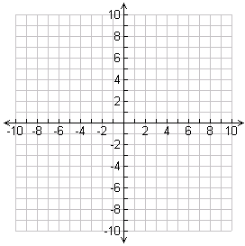

1. radians
2. radians

