Standard ASSE.2 7.3 Multiplying Special Cases Unit 7
SWBAT expand polynomials in vertex form and simplify them into standard form.

Expanding Monomials
Expand (do not simplify) each of the following:

- (2xy)²
- (5xyz)³
- (4x)⁴

The Square of a Binomial: Do NOT distribute an exponent to a binomial!
Expand, then FOIL or Box the following.

- (a – b)² =
- (a + b)² =

Expand, and then simplify the following:

- (3x + 4y)² =
- (x – 3)² =

Got it? What is the simpler form of each product?

- (2x + 9)²
- (n – 4m)²

Expanding a Binomial in Vertex Form
What is a simpler form of each product?

- 2(x – 6)²
- 3(x + 2)²
- 4(x – 1)²

What is a simpler form of each product?

- 3(x + 1)² + 1
- 2(x – 4)² – 5
- -4(x – 2)² + 6

Finding Area of Shaded Regions
Area _{shaded} = Area _{Big} – Area _{Little}

Find the area of the shaded region below. Show all work.
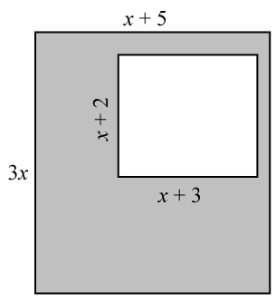

Find the area of the shaded region below. Show all work!

