Math 3 7.2 Angles, Coterminal Angles, and Reference Angles Unit 7
EQ: How can you draw positive and negative angles on the coordinate plane and determine conterminal and reference angles?

Important Vocabulary
Angle: Formed by two rays with the same endpoint Vertex: The endpoint of an angle | Standard Position: When the vertex of an angle is at the origin of the coordinate plane and one ray is on the positive x-axis  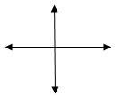
Initial Side: The ray of an angle found on the positive x-axis when the angle is in standard position | Terminal Side: The ray of an angle not found on the positive x-axis when the angle is in standard position (where the angle ends)
Positive Angles: Angles with degrees greater than 0 (counterclockwise) | Negative Angles: Angles with degrees less than o (clockwise)

Example 1: Draw an angle with the given measure in standard position.
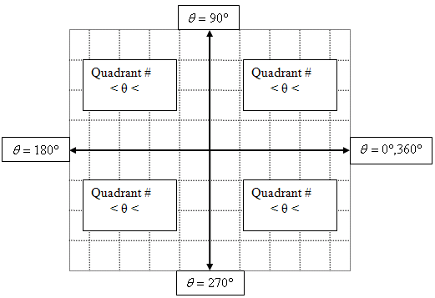

- 70º
- -135º

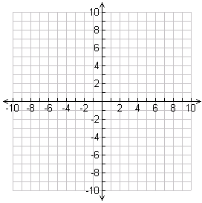

- -31º
- 117 º

Coterminal Angles: Two angles in standard position that share the same terminal side
- To find positive coterminal angles:
- To find negative coterminal angles:
Example 2: Find the measure of a coterminal angle with the listed angle.

- Find two positive coterminal angles with -410º

- Find two negative coterminal angles 579º

- Find one positive and one negative coterminal angles with 227º

- Find the measure of an angle between 0 and 360º with -321º

- Find the measure of an angle between 0 and 360º with 1054º

Reference Angle: The positive angle measure created with the terminal side of the angle and the x-axis.

Example 3: Sketch a graph each of the following in standard position. Be sure that your swoosh marks match the number of turns around the unit circle. Then, find the reference angle.

- -460º
- 553º

- -1000º
- 1000º

