Math 1 7.1 Adding and Subtracting Polynomials Unit 7

Important Vocabulary
Monomial:
Polynomial:
Degree of a Polynomial: | The ________________________ of all the exponents within the polynomial.
Standard for of a Polynomial:

Classifying Polynomials

Polynomial | Degree | Number of Terms | Term Name
6
5x + 9
4x² + 7x + 3
2x³
8x⁴ – 2x³ + 3x

Write each polynomial in standard form. What is the name of the polynomial based on its number of terms?

- 3x + 4x²
- 4x-1+5x³ + 7x

- Write 2x – 3 + 8x² in standard form. What is the name of the polynomial based on its degree and number of terms?

- How does writing a polynomial in standard form help you name the polynomial?

To ADD – combine like terms

- (4a² + 7a – 12) + (9a² – 6 + 2a)
- (3a² – 3ab – b²) + (4ab + 6b²)

To SUBTRACT – distribute a –1 then combine like terms

- (6a² – 8a + 12b³) – (-11a² + 6b³)
- (7a – 10b) – (3a + 4b)

- 7p – (9p + 3w)
- (12x – 19y) – 10y

Application – Perimeter of Figures

- Find the perimeter of the triangle below.
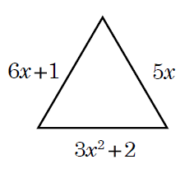

- Find the perimeter of the rectangle below.

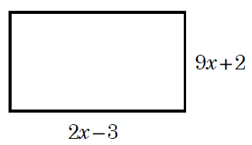

- If the perimeter of a triangle is 8x – 11, what is the length of the missing side of the triangle?

