Math 3 7.10 The Tangent Function Unit 7

*SWBAT graph the tangent function on the coordinate plane.*

|  |  |  |
| --- | --- | --- |
| Important Vocabulary | Graphing Information | The Tangent Function |
| ***Amplitude:*** *Half the difference of the maximum and minimum values of the graph* | ***The Five Key Points:*** |  |
| ***Cycle:*** *One complete pattern in a graph* | **Key  Points:** |  |
| ***Period:*** *How long it takes to complete a cycle before the pattern repeats itself*    *The period is also the distance from one asymptote to another!* | ***To find the values on the x-axis:***  *Multiply by the reciprocal of b*  ***To find the values on the y-axis:***  *Multiply by “a”* |
| **Vertical Asymptotes:** Where the tangent of the graph is _______________________ (or where the denominator is zero) | |

**Example 1:** Find the value of . Use your unit circle to find the values of  and .



1.  radians sin = cos = =_________ =
2.  radians sin = cos = =_________ =
3.  radians sin = cos = =_________ =
4. radians sin = cos = =_________ =

**Example 2:** Identify the period and determine where two asymptotes occur for each function.

1.  b = period = Asymptotes:



1. b = period = Asymptotes:

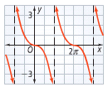**Example 3:**  Write an equation of a tangent function for the graph.

Period = Asymptotes = a = b =

Equation:

**Example 4:** Sketch one cycle of the tangent graph 

a = b = Period = Asymptotes =

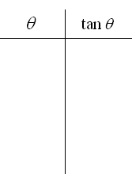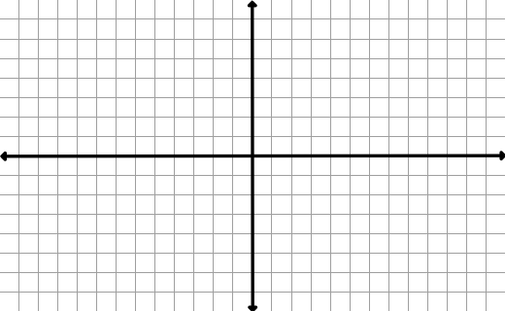

**Example 5:** Sketch one cycle of the tangent graph 

a = b = Period = Asymptotes =

