Math 3 7.11 Applications of Trigonometry (Part 2) Unit 7
EQ: How can you analyze real-life situations to create trigonometric functions and graph them on the coordinate plane?

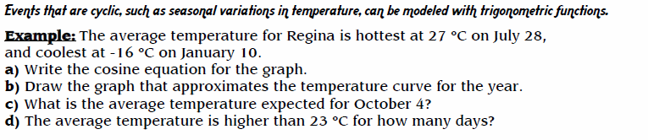
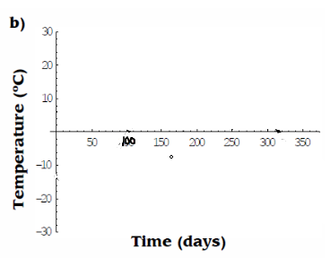
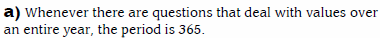

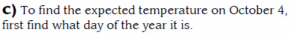
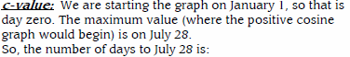

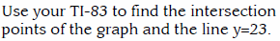

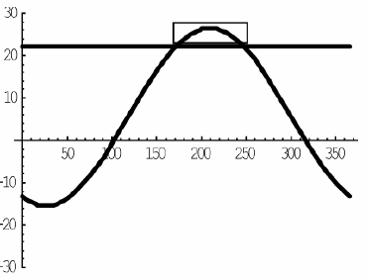

Equation of the Average Temp is:

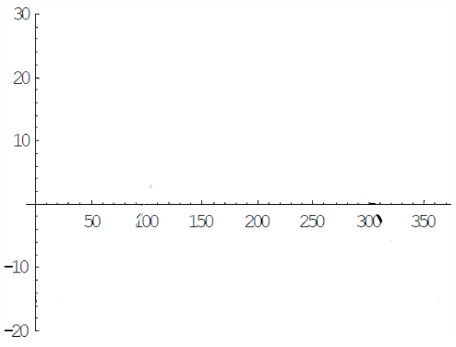

b) Draw the graph that approximates the temperature curve for the year.

c) What is the average temperature expected for November 4?
d) The average temperature is below 0*C for how many days?

2.
