Math 3 6.7 Graphing Exponentials and Logs Unit 6
SWBAT graph exponential and logarithmic functions on the coordinate plane.

Example 1: Find the inverse of the following. Remember, swap x and y, and solve for y again!

- y = log₅x
- y = log₇x - 1

- y = log₃(x-2)
- y = log₄(x + 3) – 8

Exponential Function |  | Logarithmic Function
A function whose unknown (x) is located in the exponent |  | The inverse function of an exponential function.
Transformations: y = a(b)^{(x-h)} + k |  | Transformations: y = a∙log_{b}(x-h)+k
Domain: |  | Domain:
Range: |  | Range:
Asymptote: |  | Asymptote:

Example 2: Graphing Exponential Functions
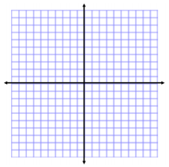

- Graph $y= 2^{x+3}-5$

Transformations:

Asymptote:

Domain:

Range:

End Behavior:
- Graph $y= -3^{x-1}+6$

Transformations:

Asymptote:

Domain:

Range:

End Behavior:

Example 2: Graphing Logarithmic Functions
- Graph y = log₂x -3

Transformations:

Asymptote:

Domain:

Range:

End Behavior:

- Graph y = –log₄(x +4) + 2
Transformations:

Asymptote:

Domain:

Range:

End Behavior:

