Math 3 6.7 Cross Sections and Rotations Unit 6
EQ: How can we identify the geometric cross section of a 3-D figure and determine the rotational image of a 2-D figure?

Cross Section: A surface or shape that would be exposed by making a straight cut through something, especially at right angles to an axis.
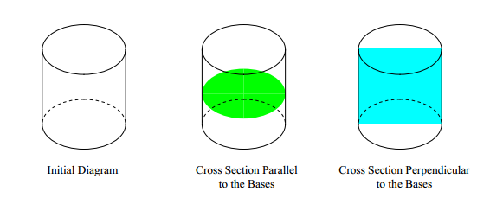

Example 1: What is the vertical cross-section going through the center of the figure shown?
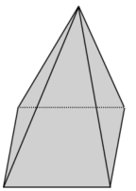
- Triangle
- Circle
- Square
- Trapezoid

Example 2: Daniel cut the corner off a cube as shown in the diagram below. Points A, B, and C are the midpoints of the edges of the cube. What type of three-dimensional figure has been cut off?
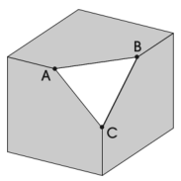
- Cone
- Cube
- Triangular prism
- Triangular pyramid

Example 3: A right circular cone is represented by the drawing below. Which figure could not be a cross section of a right circular cone?
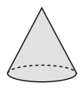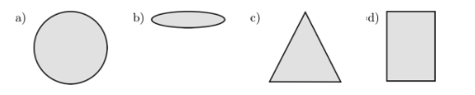

Example 4: What 3-dimensional figure do you get when you rotate a rectangle 360°?

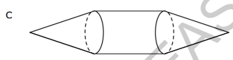
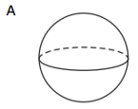
Example 5: Kathleen rotated an isosceles trapezoid 360° around its longest base. Which choice could be the resulting sold?

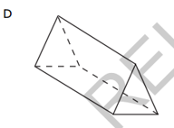
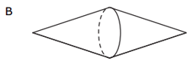

Math 3 6.8 Density Unit 6
EQ: How can we find the population density and apply it to real-life situations?

- A 4800 sq.ft. school was opened up in a small town. At the time of the school’s opening, the population density of the school was only 0.046 students/ft². Over the years, the town has seen an increase in residents, and now, it is time to decide if there should be a new school built or not. The principal determined that if population density of the school reached a level greater than 0.1 students/ft², then an additional school would need to be built. How many students were enrolled when the school first opened? If 176 new students have enrolled since the school was first opened, what can be said about the need for building a new school?

- There is an island located off the coast of South America that is approximately 4500 sq. miles and contains 608,000 inhabitants. According to the previous year’s hospital records 11,275 children were born last year, but 9850 inhabitants died. The local government of the island believes that they can support a population that is as dense as 135 people per square mile. Given last year’s medical records can the government support the new population?

- A skating rink in the shape of a circle has a diameter of 160 ft. The owner of the rink realized there were more injuries on the rink floor when the population density increased. On any given Saturday, he found that at 2 PM the population density was at 0.0096 people/ft², and at 6 PM, there were 265 people out in the rink. Was it more dangerous to be on the rink at 2PM or at 6 PM? How do you know? (Use 3.14 for π).

Fill in the appropriate dimensions for the boxes with question marks in the chart below. Be sure to include units as part of your final answer. Round all answers to the nearest hundredth and use 3.14 for π. Formula:
 | Object | Length | Width or Diameter | Height | Mass | Volume | Density
4. | Cube of Paper | 5 cm | 5 cm | 5 cm |  | 125 cm³ | 0.72 g/(cm³)
5. | Pencil |  | 0.06 cm | N/A* | 4 g |  | 80 g/(cm³)
6. | Square Pyramid | 27.5 ft | 27.5 ft | 455 ft | 110,000 kg
7. | Ice Cream Cone | N/A* |  | 14 cm | 42 g |  | 0.23 g/(cm³)
8. | Baseball | N/A* |  | N/A* | 363 g | 267.9 cm³
*N/A means not applicable. You cannot find this value for the specified object.

