Math 3 6.6 Surface Area and Volume Unit 6
EQ: How do we find the surface area and volume of geometric figures?

Volume | Prism | Cylinder | Cone | Sphere | Pyramid
 | Note: B = area of the base

Volume of Regular Figures
Find the volume of the following figures. Show all work.
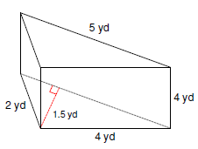
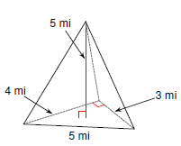

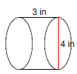
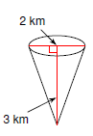

- You buy two cylindrical candles with different dimensions. Candle A has a diameter of 4 inches and a height 8 inches. Candle B has a diameter of 6 and a height of 5. Which candle contains more wax?

- If one guppy requires 5 L of water to live happily, what is the maximum number of guppies that should be kept in this aquarium?
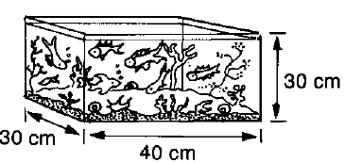

Surface Area | Prism | Cylinder | Cone | Sphere
 | B = area of the base p = perimeter of base $l$ = slant height

Lateral Area: The area of the sides of a three-dimensional figure. This area excludes the area of the base(s).

Surface Area of Regular Figures
Find the surface area of the following figures. Show all work.
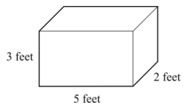
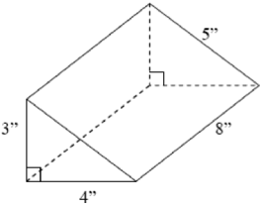

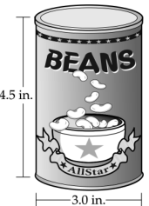
- A cylindrical can of beans is shown below. What is the area of the label that surrounds the can without overlapping? Round answer of the nearest tenth of a square inch.

- What is the lateral area of the cone shown?

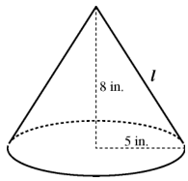

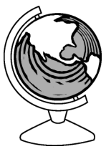
- A classroom globe as a diameter of 18 inches. Find the approximate surface area, in square inches, of the globe.

