Math 3 6.5 Parallelograms Unit 6
EQ: How can we prove a figure to be a parallelogram and solve for variables in a parallelogram?

Properties of Parallelograms
Sides | A parallelogram is a quadrilateral with both pairs of opposite sides parallel. | 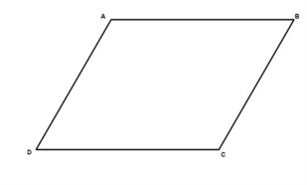
If a quadrilateral is a parallelogram,
the 2 pairs of opposite sides are congruent.
Angles | If a quadrilateral is a parallelogram,  the 2 pairs of opposite angles are congruent.
If a quadrilateral is a parallelogram,
the consecutive angles are supplementary.
If a quadrilateral is a parallelogram and one angle is a right angle,
then all angles are right angles.
Diagonals | If a quadrilateral is a parallelogram,  the diagonals bisect each other.
If a quadrilateral is a parallelogram,
the diagonals form two congruent triangles.

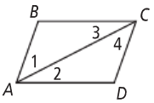
Example 1: Given: ▭ABCD is a parallelogram.
Prove: AB $≅$ CD and BC $≅$ DA.

Statement | Reason
- ABCD is a parallelogram | 1.
2. | 2. Definition of a parallelogram
- ∠1 $≅$ ∠4, ∠3 $≅$ ∠2 | 3.
4. AC $≅$ AC | 4.
5. ∆ABC $≅$ ∆CDA | 5.
6. | 6. CPCTC
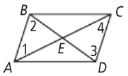
Example 2: Given: ▭ABCD is a parallelogram.
Prove: AC and BD bisect each other at E.

Statement | Reason
1. ABCD is a parallelogram | 1. Given
2. AB $∥$ DC | 2.
3. ∠1 $≅$ ∠4, ∠2 $≅$ ∠3 | 3.
4. AB = DC | 4.
5. | 5. ASA
6. AE $≅$ CE, BE $≅$ DE | 6.
7. | 7. Definition of midpoint
8. | 8. Definition of bisector

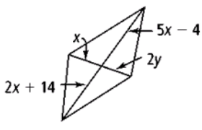
Example 3: For what values of x and y must each figure be a parallelogram?
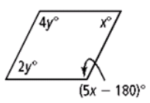

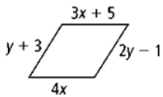
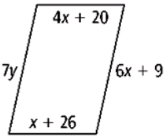

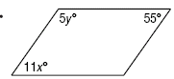
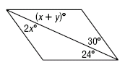

Math 3 6.5 Quadrilaterals Unit 6
EQ: How can we use the properties of quadrilaterals to solve for unknowns?

Rectangle | Rhombus | Square
A rectangle is a parallelogram with four right angles. | A rhombus is a parallelogram with four congruent sides. | A square is a parallelogram with four congruent sides and four right angles.
A rectangle has all the properties of a parallelogram PLUS:  - 4 right angles  - Diagonals are congruent  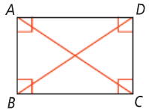 | A rhombus has all the properties of a parallelogram PLUS:  - 4 congruent sides  - Diagonals bisect angles  - Diagonals are perpendicular  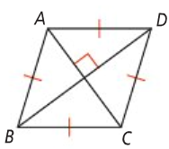 | A square has all the properties of a parallelogram PLUS:  - All the properties of a rectangle  - All the properties of a rhombus  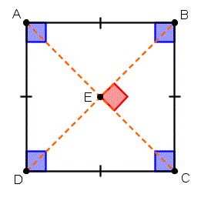

Example 1: Solve for x and the measure of each angle if ▭DGFE is a rectangle.
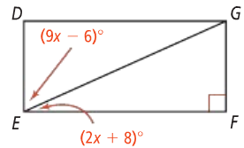

Example 2: ▭ABCD is a rectangle whose diagonals intersect at point E.

- If AE = 36 and CE = 2x – 4, find x.

- If BE = 6y + 2 and CE = 4y + 6, find y.

Example 3: Using the diagram to the right to answer the following if ▭ABCD is a rhombus.
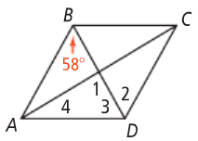

- Find the m∠1.
- Find the m∠2.

- Find the m∠3.
- Find the m∠4.

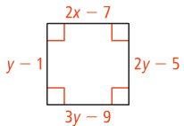
Example 4: Solve for each variable if the following are rhombi.

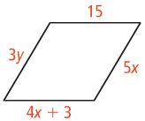

Trapezoid | A trapezoid is a quadrilateral with exactly one pair of parallel sides, called bases, and two nonparallel sides, called legs. | Isosceles Trapezoids | Trapezoid Midsegment
 |  | An isosceles trapezoid is a trapezoid with congruent legs. | The median (also called the midsegment) of a trapezoid is a segment that connects the midpoint of one leg to the midpoint of the other leg.
 |  | A trapezoid is isosceles if there is only:  - One set of parallel sides  - Base angles are congruent  - Legs are congruent  - Diagonals are congruent  - Opposite angles are supplementary | Theorem: If a quadrilateral is a trapezoid, then a) the midsegment is parallel to the bases and b) the length of the midsegment is half the sum of the lengths of the bases
 |  | 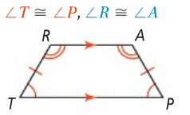 | 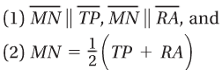  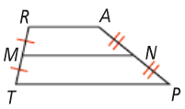

Example 5: CDEP is an isosceles trapezoid and m<C = 65. What are m<D, m<E, and m<F?
Example 6: What are the values of x and y in the isosceles triangle below if DE || DC?

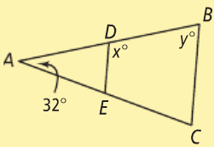
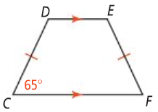

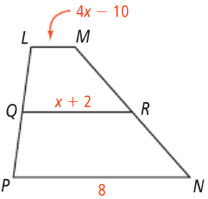
Example 7: QR is the midsegment of trapezoid LMNP. What is x and the length of LM?
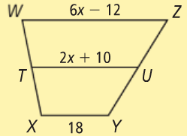
You Try! TU is the midsegment of trapezoid WXYZ. What is x and the length of TU?

