Math 1 6.2 The Pythagorean Theorem Unit 6

Pythagorean Theorem: A method used to solve for a missing length of a right triangle.
Legs: The two shorter sides of a right triangle
Hypotenuse: The longest side of a right triangle, located across from the ______________ angle.

The Pythagorean Theorem

a² + b² = c²
Where “a” and “b” are the legs of a triangle, and “c” is the hypotenuse.

Solving for a Hypotenuse
Solve for the length of the hypotenuse in each of the following:

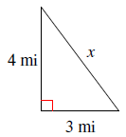
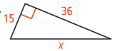

- A square tile has side lengths of 6 inches. What is the length of the tiles hypotenuse if it is cut along one of its diagonals?

Solving for a Missing Leg Length
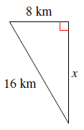
Solve for the length of the missing leg in each of the following:

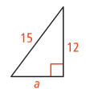
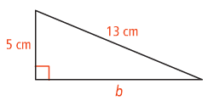

Determining if a Triangle is Right
Determine if each of the following are right triangles by using the Pythagorean Theorem.
Step 1: Determine what your longest side is and set that equal to “c”
Step 2: Set up the Pythagorean Theorem with the two shorter sides as “a” and “b”
Step 3: Determine if the two sides of the equation are equal
- If they are equal, then you have a right triangle
- If they are not equal, then you do not have a right triangle
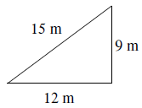
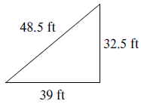

- 20cm, 47cm, 52cm

The Pythagorean Theorem – Word Problems!!

- The hypotenuse of a right triangle is 45cm, and one of its legs is 36cm. Find its perimeter.

- A fifteen-foot ladder reaches the top of a 13-ft wall. How far is the base of the ladder from the base of the wall?

- If you drive 3 miles west, then 5 miles south, and finally 15 miles east, how far will you end up from where you started?

- An isosceles triangle has two congruent 11-inch sides, and an 18-inch base. What is its approximate area?

- Addison is standing in the middle of a large field throwing baseballs. He throws the first ball 20 yards straight out. He turns 90 degrees to the right and throws a second ball 23 yards straight out. He turns 90 degrees to the right again and throws a third ball 45 yards straight out. What is the shortest distance he can walk to retrieve all three balls (he does not need to return to his original spot). Round to the nearest tenth.

Challenge: A rectangle is nine inches longer than it is wide, and its diagonal is 10 inches longer than its width. What is the width of the quadrilateral? (Round answer to the nearest hundredth).

