Math 3 6.1 Intro to Geometric Properties Unit 6

*EQ: How do we examine the properties of lines and angles?*

**Directions:** Match each of the following pictures with the vocabulary listed below.

1. 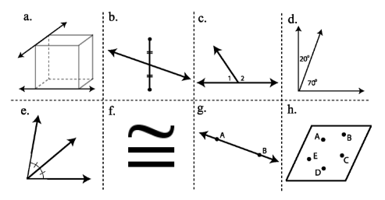_____ Line AB
2. ______ Linear Pair Angles
3. ______ Coplanar points
4. _____ Congruent (Symbol)
5. _____ Skew lines
6. _____ Complementary Angles
7. _____ Segment bisector
8. _____Angle bisector

|  |  |  |  |  |
| --- | --- | --- | --- | --- |
| Congruent Angles | **Name:** | **Definition:** | **Example:** | **Picture:** |
| Vertical Angles: |  |  |  |
| Corresponding Angles: |  |  |
| Alternate Interior Angles: |  |  |
| Alternate Exterior Angles: |  |  |
| Supplementary Angles | Linear Pair: |  |  |  |
| Consecutive Interior Angles: |  |  |
| Consecutive Exterior Angles: |  |  |

|  |  |  |  |  |  |  |
| --- | --- | --- | --- | --- | --- | --- |
| Classifying Triangles | Angles | | | Sides | | |
| Name | | | Name | | |
|  |  |  |  |  |  |
| Picture | | | Picture | | |
|  |  |  |  |  |  |
| Definition | | | Definition | | |
|  |  |  |  |  |  |

