Math 1 5.7 Exponential Functions Unit 5 Day 5
SWBAT graph exponential functions and determine all vertical shifts.

Introduction to Exponential Functions
Nyasia has been hired by a company that pays her 2 cents on the first day and then doubles her pay each day after the first.

- Complete the chart to determine how much Nyasia makes, in cents, each day.
Day | 1 | 2 | 3 | 4 | 5 | 6 | 10 | 30 | 50
Pay

- Write a formula to calculate the pay, p, as a function of day, d.

This is an example of an exponential function since the independent variable (days) is the exponent. Notice how fast the values of the pay are increasing. This is what is known as exponential growth.

Rules of Exponential Functions
Exponential Form: $y=a({b)}^{x}+k$

a = _____________________ or _____________________ Exponential Growth Exponential Decay
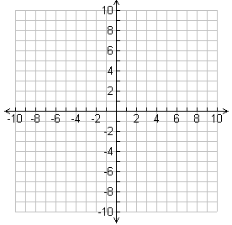
b = Growth or Decay factor
- Growth:
- Decay:
Key Point (y-intercept):

Graphing

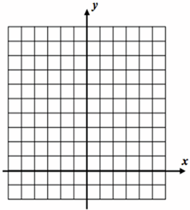
- Consider the function y = 2^{x}
- Consider the function y = (1/2)^{x}

x | y
-3
-2
-1
0
1
2
3
x | y
-3
-2
-1
0
1
2
3

How do the two graphs compare to each other? What differences do you notice?
Graphing Vertical Shifts: All exponentials run through the point (0, 1) unless they have been vertically shifted.

- Graph the function f(x) = 2^{x} + 3
Asymptote: _____________
- Graph the function f(x) = 2^{x} – 1
Asymptote: _____________

x | y
-1
0
1
2
3
4
5
x | y
-1
0
1
2
3
4
5

Vertical Shift EOC-Type Questions (non-calculator)

- The function f(x) = 4^{x} was replaced with
f(x) + k, resulting in the function graphed to the right. What is the value of k?
- The function f(x) = 3^{x} was replaced with
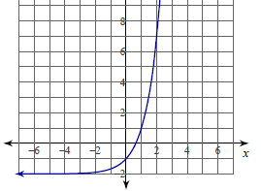
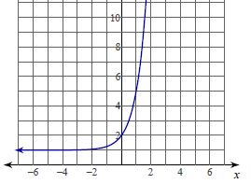
f(x) + k, resulting in the function graphed to the right. What is the value of k?

Determining Whether a Function is Exponential
Does the table or rule represent an exponential function? Explain.

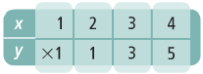

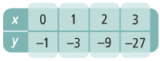

- $y=3x^{2}$

- $y=3∙6^{x}$

Evaluating an Exponential Function
Suppose 30 flour beetles are left undisturbed in a warehouse bin. The beetle population doubles each week. The function f(x) = 30(2)^{x} give the population after x weeks. How many beetles will there be after 56 days?

An initial population of 20 rabbits triples every half year. The function f(x) = 20(3)^{x} gives the population after x half-year periods. How many rabbits will there be after 3 years?

