Math 3 **5.5 Graphing Rational Expressions** Unit 5

*EQ: How do you graph rational expressions, state points of discontinuity, and find any horizontal or vertical asymptotes?*

**Example 1:** Simplify the following. State any restrictions on the variables.

1.  b) 

|  |
| --- |
| **Vertical Asymptotes**: Where the __________________ of a function equals zero.  **Point of Discontinuity:** A _____________ in the graph. |

**Example 2:** Determine the equations of any vertical asymptotes and the values of x for any holes in the graph of .

**Example 3:** Determine the equations of any vertical asymptotes and the values of x for any holes in the graph of 

**Horizontal Asymptotes:** determined by comparing the degree of the numerator to the degree of the denominator. Let ***m*** = degree of numerator and ***n***= degree of denominator.

|  |  |
| --- | --- |
| If… | Then the graph has… |
| *m* < n $$f\left(x\right)=\frac{x+4}{x^{2}+ 5x+4}$$ | A horizontal asymptote at y = 0  V.A.:_____________________ Hole(s): __________________  H.A.:_____________________ Domain:____________________________________ |
| m = n $$f\left(x\right)=\frac{x^{2}+ 5x+4}{4x^{2}-9}$$ | A horizontal asymptote at the coefficient of m divided by  the coefficient of n  V.A.:_____________________ Hole(s): __________________  H.A.:_____________________ Domain:____________________________________ |
| m > n $$f\left(x\right)=\frac{x^{2}+ 5x+4}{x+4}$$ | No horizontal asymptote    V.A.:_____________________ Hole(s): __________________  H.A.:_____________________ Domain:____________________________________ |

**Example 4:** State the asymptotes and points of discontinuity of each equation, and then graph the function and state the domain.

1. 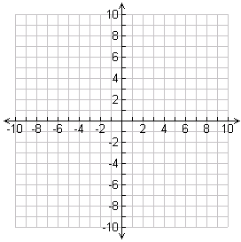
2. 



1. 
2. 



1. 
2. 