START! | 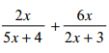 | Answer:  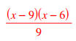 | 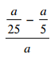
Answer:  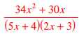 | 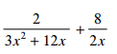 | Answer:  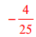 | 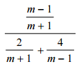
Answer:  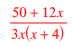 | 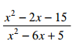 | Answer:  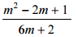 | 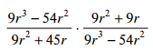
Answer:  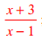 | 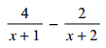 | Answer:  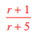 | 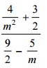
Answer:  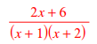 | 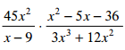 | Answer:  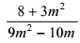 | 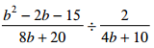
Answer: | 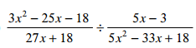 | Answer:  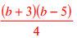 | End!

