Standard 8.EE.1 **5.3 Multiplying Powers** Unit 5 Day 2

|  |  |  |
| --- | --- | --- |
| **Multiplying Powers with the Same Base** | | |
| To multiply powers with the same base, add the exponents. |  | Examples: |

**Why it Works:** Use repeated multiplication to rewrite the product of powers: 24 x 23 = ?

1. Expand each into the product numbers below.

24  x 23 = ?

( ) x ( ) =

**Multiplying Powers**

What is each expression written using each base only once?

1. 
2. 
3. 
4. 
5. 
6. 

**Multiplying Powers in Algebraic Expressions**

What is the simplified form of each expression?

1. 
2. 

Got it? What is the simplified form of each expression in the following parts?

1. 
2. 
3. 
4. Explain how to simplify the expression

**Finding the Area of Geometric Figures**

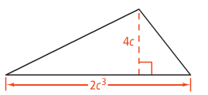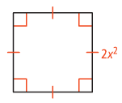Find the area of each of the following.



Standard 8.EE.1 **5.4 Power Property of Exponents**  Unit 5 Day 2

|  |  |  |
| --- | --- | --- |
| **Raising a Power to a Power** | | |
| To raise a power to a power, multiply the exponents. |  | Examples: |

**Why it Works:** Use repeated multiplication to rewrite the product of powers: (52)4 = ?

1. Expand into the product numbers LEAVING 52 as 52.

(52)4 = ( ) x ( ) x ( ) x ( )

( x ) x ( x ) x ( x ) x ( x ) =

**Simplifying a Power Raised to a Power**

What is each expression written using each base only once?

1. 
2. 
3. 
4. 
5. Is true for all integers m and n? Explain.

**Simplifying an Expression with Powers**

What is the simplified form of each expression?

1. 
2. 
3. 
4. 

|  |  |  |
| --- | --- | --- |
| **Raising a Product to a Power** | | |
| To raise a product to a power, raise each factor to the power and multiply. |  | Examples: |

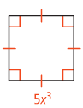

**Simplifying a Product Raised to a Power**

Find the expression that represents the area of the square.

What is the simplified form of each expression?

1. 
2. 
3. 

**Simplifying an Expression with Products**

What is the simplified form of ?

What is the simplified form of each expression?

1. 
2. 
3. 