Station A

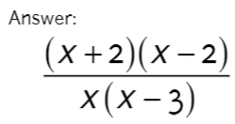

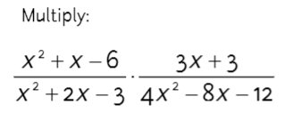

Station B

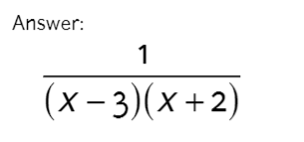

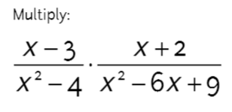

Station C

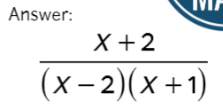

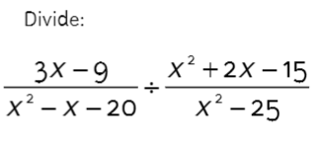

Station D

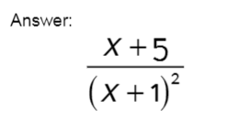

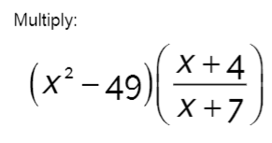

Station E

Answer:

$$\frac{3x}{x+1}$$

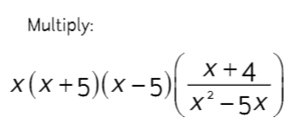

Station F

Answer:

$$\frac{3}{x+4}$$

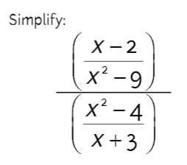

Station G

Answer:

$$(x-7)(x+4)$$

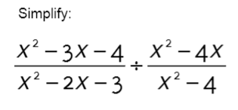

Station H

Answer:

$$\frac{3(x-2)}{4(x-1)(x-3)}$$

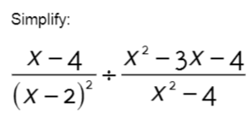

Station J

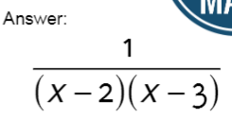

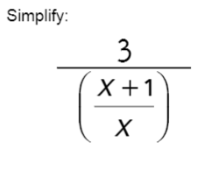

Station K

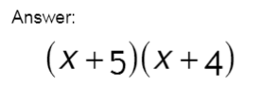

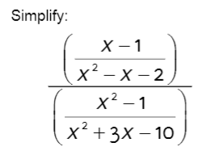

Activity 5.1: Scavenger Hunt Name: _______________________________

Math 3

**Directions:** Keep track of your progress in the table below. Show all work in the space provided.

|  |  |
| --- | --- |
|  | Station A |
| Station B | Station C |
| Station D | Station E |

|  |  |
| --- | --- |
|  | Station F |
| Station G | Station H |
| Station J | Station K |