Math 3 4.8 Solving Polynomials Unit 4
EQ: How can you apply your knowledge of the Fundamental Theorem of Algebra to find the factors and roots of polynomials?

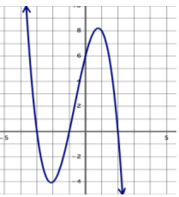
Example 1: Write everything you know about the following polynomial.

In case this was not part of what you wrote, use function notation to highlight values of importance for this function (i.e. f(0) = 6).

Example 2: Without using a calculator, find all linear factors and then determine all roots of the function. Sketch a graph with this information.

- f(x) = x³ + 3x² – 4x – 12 Factors: Roots: Graph:

- f(x) = x³ – 3x² + x – 3 Factors: Roots: Graph:

- f(x) = x³ + x² + 4x + 4 Factors: Roots: Graph:

- f(x) = x⁵ – 8x³ – 9x Factors: Roots: Graph:

Example 3: Using the given factor, find all remaining factors and then determine all roots of the function. Sketch a graph with this information.

- f(x) = x³ + 4x² + x – 6 Factor: (x + 3) Roots: Graph:

- f(x) = x³ – 5x² + 2x + 8 Factor: (x – 2) Roots: Graph:

- f(x) = x³ + 6x² + 11x + 6 Factor: (x + 1) Roots: Graph:

- f(x) = x⁴ + 4x³ + 7x² + 16x + 12 Factor: (x + 1) Roots: Graph:

- f(x) = x⁴ – 4x³ + x² + 12x – 12 Factor: (x – 2) Roots: Graph:

