Math 1 4.7 Regression Application Unit 4
SWBAT find the line of best fit and use it to predict future values.

Trend Line: A line on a scatter plot, drawn near the points, that shoes a correlation.
Line of Best Fit: a trend line that shows the relationship between two sets of data most accurately
Interpolation: Estimating a value between two known values.
Extrapolation: Predicating a value outside the range of know values.

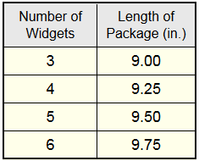
- The relationship between the number of widgets in a package and the length of the package, in inches, in given in the table at the right.

  - What is the slope of the line of best fit?

  - What is the value of the y-intercept of the line of best fit?

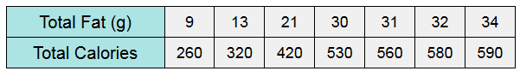
- The table shows the relationship between total fat grams and the total calories in a selection of fast food sandwiches. Find the linear regression equation that models this data (Round to the nearest integer).

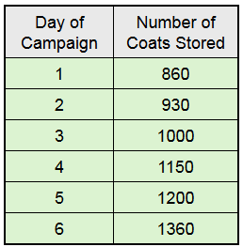
- A morning radio ralk show is running a “Winder Coat Campaign” to collect and deliver coast to local shelters. They are storing the coats until they reach their goal of 2100 coats. The table at the right shows the number of coats in storage at the end of each day of the campaign.

  - Write the linear regression equation for this data (rounded to the nearest hundredth).

  - Using the equation from part a, predict the day the campaign will meet its goal and the coats will be delivered to the shelters.

  - Using the equation from part a, predict the number of coats the campaign will have on the 12 day.

- A research study finds that fat calories in hamburgers have a positive linear association with the amount of sodium found in the hamburger. This finding indicates that: (choose the best answer)
  - Low amounts of sodium in hamburgers indicates a high number of fat calories in hamburgers
  - High amounts of sodium in hamburgers cause high amounts of fat calories in hamburgers
  - Hamburgers with low amounts of fat calories tend to have low amounts of sodium
  - Hamburgers with low amounts of fat calories have high amounts of sodium
As the number of farms has decreased in the United States, the average size of the remaining farms has grown larger, as shown in the table below.
Year | 1910 | 1920 | 1930 | 1940 | 1950 | 1959 | 1969 | 1978 | 1987 | 1997
Average Acre per Farm | 139 | 149 | 157 | 175 | 216 | 303 | 390 | 449 | 462 | 487

- Make a scatterplot of the data, letting x represent the number of years since 1900.

- Using a graphing calculator, find the line of best fit. Round to the nearest hundredth if necessary.

- Predict the average acreage in the year 2000. Round to the nearest whole number.

- Predict the average acreage in 2010. Round to the nearest whole number.

- What was the average acreage in 1810 (to the nearest integer)? Is this reasonable? Explain why or why not.

CHALLENGE: EOC-Type Question
