Math 1 4.6 Scatter Plots (Regression) Unit 4

Independent Variables:
Dependent Variables:
Scatter Plot: A graph that relates two different sets of data by displaying them as ordered pairs.

2

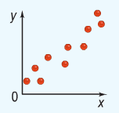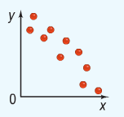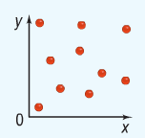

___________________________ ___________________________ ___________________________

Making a Scatter Plot and Describing Its Correlation
Determine the correlation between the points in the tables listed below.

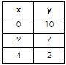
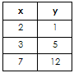
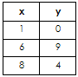

Relationship: ________________________ Relationship: _______________________ Relationship: _______________________

Line of Best Fit: A line on a scatter plot, drawn near the points, that shoes a correlation.

How to Create a Line of Best Fit in the Calculator:

Step 1: Clear your calculator (2nd plus 7, 1, 2)
Step 2: Turn STATPLOT on (2nd y= ON)
Step 3: 2nd Mode
Step 4: STAT Enter
Step 5: Enter Data into L₁ and L₂
Step 6: STAT CALC 4 Enter
Step 7: Substitute the values of “a” and “b” into the equation

Example: Find the equation of the line of best fit given the data below.

Equation: ________________________

Slope: ___________________________

Y-intercept: ______________________

Equation: ________________________

Slope: ___________________________

Y-intercept: ______________________

Equation: ________________________

Slope: ___________________________

Y-intercept: ______________________

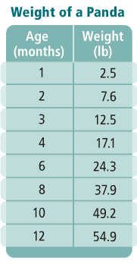
Writing an Equation of a Trend Line: Make a scatter plot of the data at the right. Then, find the line of best fit
- Equation of the Line of Best Fit: ____________________________________________________

- What does the slope mean in the context of the problem?

- What does the y-intercept mean in the context of the problem?

EOC-Related Questions

- Taylor compared the y-intercept of the graph of the function f(x) = 5x + 7 to the y-intercept of the graph of the linear function that includes the points from the table below. What is the difference when the y-intercept of f(x) is subtracted from the y-intercept of g(x)?
x | -5 | -3 | -1 | 1
f(x) | 4 | 5 | 6 | 7

- What is product with the slope of f(x) = -7x + 12 is multiplied with the slope of g(x), given the table below?
x | -2 | 0 | 2 | 3 | 4
g(x) | 7 | 5 | 3 | 2 | 1

- What is the sum of the slope from h(x) = 12x – 6 and the y-intercept of d(x), given the table below?

x | -15 | -6 | 2 | 7 | 12
g(x) | 4 | 6 | 12 | 15 | 20

- (Multiple Choice) The boiling point of water, T (measured in degrees), at an altitude a (measured in feet) is modeled by the function T(a) = -0.0018a + 212. In terms of altitude and temperature, which statement describes the meaning of the slope?

  - The boiling point increases by 18 degrees as the altitude increases by 1,000 feet.
  - The boiling point increases by 1.8 degrees as the altitude increases by 1,000 feet.
  - The boiling point decreases by 18 degrees as the altitude increases by 1,000 feet.
  - The boiling point decreases by 1.8 degrees as the altitude increase by 1,000 feet.

