Math 3 4.6 Polynomial Expansion Unit 4
SWBAT expand and simplify polynomials using Pascal’s Triangle.

Example 1: Rewrite each of the problems in expanded form and then simplify the polynomial.

- f(x) = x + 1
- f(x) = (x + 1)²
- f(x) = (x + 1)³

Pascal’s Triangle
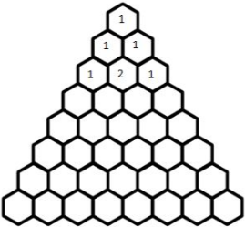
Expanding polynomials might seem easy, but imagine if you had a polynomial raised to the 10th degree, or the 100th. Pascal’s Triangle is a way of expanding polynomials without having to foil a bunch of times.

Example 1: Expand and simplify: (x + y)⁵

Example 2: Expand and simplify: (2x - y)³

Example 3: Expand and simplify: (2m – 1)⁴

Example 4: Expand and simplify: (x – 3y)⁵

