Math 3 4.6 Polynomials in the Real World Unit 4
SWBAT create polynomial equations and use them to solve real-life questions.

We can determine a line of best fit from a set of data by plugging in our information into the STAT and comparing our Correlation Coefficients (r²). The closer the r² is to 1, the “better fit” our data is. To turn the r² on, press 2nd 0, and scroll down to “DiagnosticOn.” Hit enter twice, and then plug in the information as usual.

Example 1: Find a polynomial function whose graph passes through the set of points (-1, 8), (5, -4), and (7, 8)
- Linear: r² =

- Quadratic: r² =

- Cubic: r² =

- Quartic: r² =

Example 2: Find a quadratic, cubic, and a quartic model for each set of values. Round each equation to the nearest hundredth.
x | -2 | -1 | 0 | 1 | 2
y | -65 | -14 | -4 | 2 | 90

- What is the quadratic model that represents this data?

- What is the cubic model that represents this data?

- What is the quartic model that represents this data?

- Which model best represents this data? Explain your reasoning.
- Using the model of best fit, predict the y-value when x = 8.

Example 3: The table below shows the percentage of the U.S. labor force in unions for selected years between1955 and 2005.
Year | 1955 | 1960 | 1965 | 1970 | 1975 | 1980 | 1985 | 1990 | 1995 | 2000 | 2005
% | 33.2 | 31.4 | 28.4 | 27.3 | 25.5 | 21.9 | 18.0 | 16.1 | 14.9 | 13.5 | 12.5

- What is the linear model that represents this data? Round to the nearest hundredth.

- What is the quadratic model that represents this data? Round to the nearest hundredth.

- What is the cubic model that represents this data? Round to the nearest hundredth.

- Which model best represents this data? Explain your reasoning.
- Using the model of best fit, estimate the percentage of people in unions in 2015.

Maximizing Volume – Box Construction

- Given an 8.5 inch by 11 inch rectangular piece of paper, design a box with an open top and calculate the volume. Complete the chart to see what happens to the volume of a box as our depth, “x”, increases. **Remember, V =lwh

Depth (in.) | Length (in.) | Width (in.) | Volume (in³)
0 |  |  | 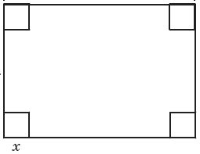
1
2
3
4
x

- Write an equation in factored form to represent the volume of a box given “x” depth in inches.

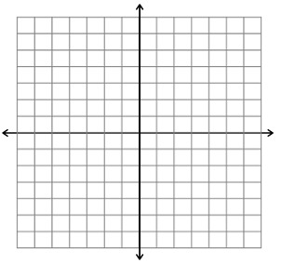
V(x) = _____________________________________________

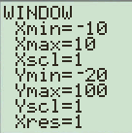
- Graph the equation in your calculator. Sketch the graph below, using the window given (change this in your calculator using the “Window” button).

- Using the information from the equation, estimate the depth, “x”, that will give the maximum volume, “y”. What is the maximum volume?

- Write an equation in factored form to represent the volume of a rectangular box formed from a 9 in. by 12 in. piece of paper given x depth in inches.

V(x) = _____________________________________________

- Graph the equation in your calculator. Using the information from the equation, estimate the depth, “x”, that will give the maximum volume, “y”. What is the maximum volume?

Practice Problems
- A rectangular sheet of cardboard measures 16cm by 6cm. Equal squares are cut out of each corner and the sides are turned up to form an open rectangular box. What is the maximum volume of the box?

- Dick’s Sporting Goods found that its monthly profit, P, is given by where x is the selling price for each set of golf clubs. Estimate the maximum price per unit of golf clubs that the company should charge to maximize their profit.

- The volume of a rectangular box is 1120 cubic feet. The width is two feet less than the height, and the length is four feet more than the height. Find the dimensions of the box.

- TJ Maxx found that its profit is given by the function where x is the selling price for each pair of jeans. Estimate the maximum price per pair of jeans that the company should charge to maximize their profits.

