AFM **4.5 Reflections and the Square Root Family** Chapter 4

**Reflection of a Function:** A transformation that flips a graph across a line, creating a mirror image.

|  |  |
| --- | --- |
| **Reflection across x-axis** | **Reflection across y-axis** |
|  |  |

**Example 1:** Given the function below, graph the reflection across the x-axis, y-axis, and across both the x- and y-axis.

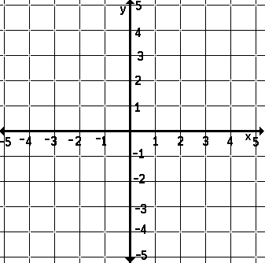

**Square Root Functions:** Have the parent function y = √x.

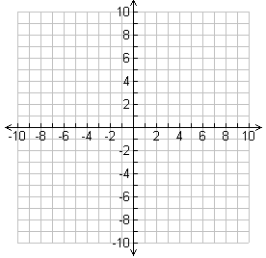

Domain:

Range:

End Behavior:

**Example 2:** Each graph below is a transformation of the graph of the parent function y = √x. Write an equation for each graph, and then state the domain and range.

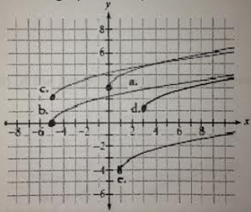

1. Domain: Range:
2. Domain: Range:
3. Domain: Range:
4. Domain: Range:
5. Domain: Range:

**Example 3:** Describe what happens to the graph of y = √x in the following situations.

1. x is replaced with (x + 5)
2. x is replaced with (x – 5)
3. y is replaced with (y + 3)
4. y is replaced with (y – 3)

**Example 4:** Use the function h = -16t2 + d, where d is the initial height and h(t) is the height after *t* seconds, to answer each equation. Round answers to the nearest hundredth of a second.

1. If a ball is dropped from a height of 700 feet, how long will it take to reach a height of 500 feet?
2. If a ball is dropped from a height of 900 feet, how long will it take to reach a height of 100 feet?
3. If a ball is dropped from a height of 120 feet, how long will it take to hit the ground?