Math 3 4.4 Polynomial Rates of Change Unit 4
EQ: How can we explore how quickly polynomial functions increase and decrease?

In as many ways as possible, compare and contrast linear, quadratic, and exponential functions.

Example 1: Use the following functions to help answer the statements below.

$$2^{x}$$ | $$x^{2}-20$$ | $$x^{5}-{4x}^{2}+1$$ | $$x+30$$ | $$x^{4}-1$$ | $$x^{3}+x^{2}-4$$ | $$-x^{2}+x$$

- Write the following expressions in order from least to greatest when the value of x is zero.

- Do you think this order would change when x represents other numbers?

- Write the same expressions from least to greatest when x represents a very large number (this number is so large it is close to or approaching positive infinity).

- Write the same expressions in order from least to greatest when x represents a number that is approaching negative infinity.

- When comparing expressions, how does the order change depending on the values of x (close to negative infinity, zero, and positive infinity)?

- Determine where you would insert the following expression in question c.

$${\left(\frac{1}{2}\right)}^{x}$$ | $$x^{7}$$ | $${-x}^{5}$$ | $$x^{6}$$ | $$x^{5}$$

- Now insert these same expressions into your list in question d.

- Write your process for ordering one variable polynomial expressions for both extremes (when x approaches infinity as well as when x approaches negative infinity).

End Behavior: Defined by what is going on at the ends of a graph.

 | Even Degree Polynomial | Odd Degree Polynomial
Positive  Leading Coefficient | 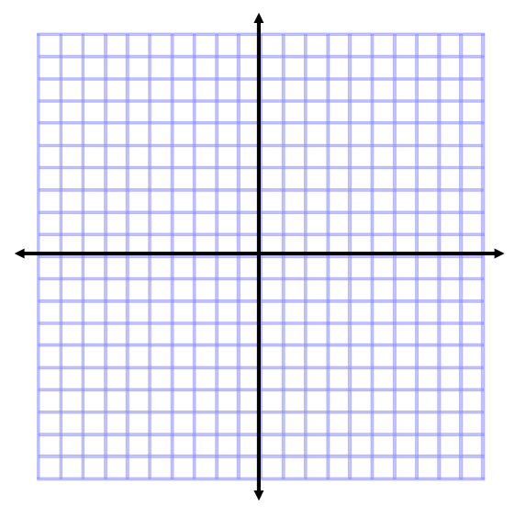
Negative
Leading Coefficient

Example 1: Find the end behavior based on your knowledge of the function.

- $f\left(x\right)=3+2x$
- $f\left(x\right)=x^{4}-16$
- $f\left(x\right)=3^{x}$

Degree:
LC:
End Behavior:
Degree:
LC:
End Behavior:
Degree:
LC:
End Behavior:

- $f\left(x\right)=x^{3}+{2x}^{2}-x+5$
- $f\left(x\right)={-2x}^{3}+{2x}^{2}-x+5$
- $f\left(x\right)=\log_{2}x$

Degree:
LC:
End Behavior:
Degree:
LC:
End Behavior:
Degree:
LC:
End Behavior:

- $f\left(x\right)=-2(x-3)(x+4)$
- $f\left(x\right)=\sqrt{x}-3$
- $f\left(x\right)=3(x-1)(x+2)(x-4)$

Degree:
LC:
End Behavior:

Degree:
LC:
End Behavior:

Degree:
LC:
End Behavior:

