Math 3 4.3 Exploring Polynomial Functions Unit 4
EQ: How can you describe key elements of a graph including domain, range, and the relative/absolute max/min?

Relative Maximum/Minimum:

Absolute Maximum/Minimum:

Example 1: Determine each of the following given the graph below.

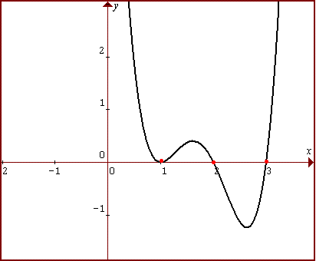
- Relative Maximum:
- Relative Minimum:
- Absolute Maximum:
- Absolute Minimum:
- Domain:
- Range:
- Intervals Increasing:
- Intervals Decreasing:

Example 2: You are drawing a rectangle with side lengths of (5 – x) and (x + 3).

- Write a polynomial function that represents the area of the rectangle.

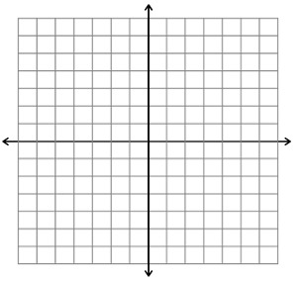

- What value of x will maximize the area?

- What is the maximum area of the rectangle?

- What is the domain of the function?

- What is the reasonable domain of the function?

- What is the interval increasing? What does it mean in this situation?

- What is the interval decreasing? What does it mean in this situation?

Maximizing Volume: Box Construction

Example 1: Given a 22 by 12 rectangular piece of graph paper, design a box with an open top and calculate the volume. Complete the chart to see what happens to the volume of a box as our depth, “x”, increases. **Remember, V =lwh

Height (in.) | Length (in.) | Width (in.) | Volume (in³)
0 |  |  | 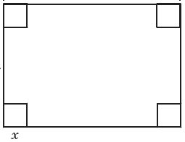
1
2
3
4
x

- Write an equation in factored form to represent the volume of a box given “x” height in inches.

V(x) = _____________________________________________

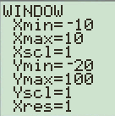
- Graph the equation in your calculator. Sketch the graph below, using the window given (change this in your calculator using the “Window” button).

- Using the information from the equation, estimate the height, “x”, that will give the maximum volume, “y”. What is the maximum volume?

- What is the reasonable domain for this function?

Example 2: Write an equation in factored form to represent the volume of a rectangular box formed from a 9 in. by 12 in. piece of paper given x depth in inches.

V(x) = _____________________________________________

- Graph the equation in your calculator. Using the information from the equation, estimate the depth, “x”, that will give the maximum volume, “y”. What is the maximum volume?

- What is the reasonable domain for this function?

Practice Problems
- A rectangular sheet of cardboard measures 16cm by 6cm. Equal squares are cut out of each corner and the sides are turned up to form an open rectangular box. What is the maximum volume of the box?

- Dick’s Sporting Goods found that its monthly profit, P, is given by where x is the selling price for each set of golf clubs. Estimate the maximum price per unit of golf clubs that the company should charge to maximize their profit.

- TJ Maxx found that its profit is given by the function where x is the selling price for each pair of jeans. Estimate the maximum price per pair of jeans that the company should charge to maximize their profits.

