Math 1 **4.3 Box-and-Whisker Plots** Unit 4

**Quartiles:**

Q1, Q2 (aka – median), and Q3

**Interquartile Range:**

**Box-and-Whisker Plot:**

**Box-and-Whisker Plot**

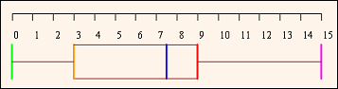

* The left whisker extends from the _____________________ to the ________ quartile. It represents about _______ % of the data.
* The box extends from the ________ quartile to the ________ quartile and has a vertical line through the ________________. The length of the box represents the _________________ range. It contains about 50% of the data.
* The right whisker extends from the _______ quartile to the ________________. It represents about ______% of the data.

**Creating Box-and-Whiskers**

1. 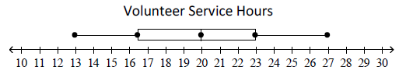The box and whisker plot below shows the volunteer service hours performed by students at Indian Trail Middle School last summer.
2. What is the median of the data set?
3. What is the lower quartile of the data set?
4. What is the upper quartile of the data set?
5. What percentage of data is between the lower quartile and the upper quartile?
6. 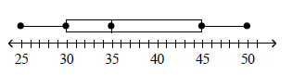Use the following box-and-whisker plot to answer the following questions.
   1. What is the median?
   2. What percentage of the data is below the median?
   3. The five values that make up the box-and-whisker plot are:
7. Create a box-and-whisker plot using the following set of data: 7, 6, 2, 7, 8, 3, 12, 9, 7, 4, 6, 7, 11

**Min: Mean:**

**Q1: Mode:**

**Median: Range:**

**Q3: Max:**

**Interpreting Box-and-Whisker Plots**

1. 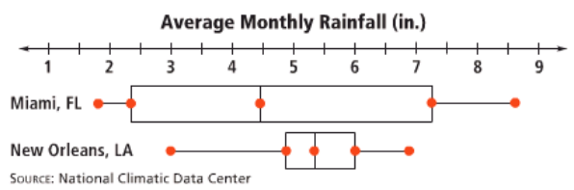Use the box-and-whisker plots below. What do the interquartile ranges tell you about eh average monthly rainfall for each city?
2. 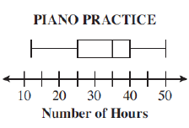Ms. Russell drew a box-and-whisker plot to display data about the number of hours her piano students practiced last month, as shown below. What whole number best represents the median number of hours her students practiced playing the piano last month?
3. 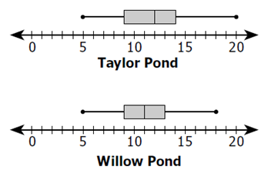Colin caught 15 fish in each of the two ponds on his ranch. The box-and-whisker plots summarize the lengths, in inches, of the fish from each pond.

**(Multiple Choice)** The lengths of the fish from Willow Pond have a:

1. Greater range than the lengths of those from Taylor Pond
2. Median equal to 12 inches
3. Mean equal to 20 inches
4. Lower quartile equal to the lower quartile of Taylor Pond
5. Each box-and-whisker plot shows the prices (in thousands of dollars) of used cars advertised for sale at three car dealerships.
   1. If you want to go to the dealer whose prices seem least expensive, which dealer would you go to?
   2. Write a sentence using summary statistics (words like mean, median, mode, quartile, etc.) to explain the car dealership that you would choose.