Math 1 4.2 Standard Deviation Unit 4
Measure of Variation: Describes how the data in a data set are _____________________.
Standard Deviation (σ): A measure of how far the numbers in a data set _____________ from the mean.

Example 1: What are the mean, variance, and standard deviation of the following values: 6.9, 8.7, 7.6, 4.8, 9.0

Example 2: The table displays the number of U.S. hurricane strikes by decade from the years 1851 to 2000.
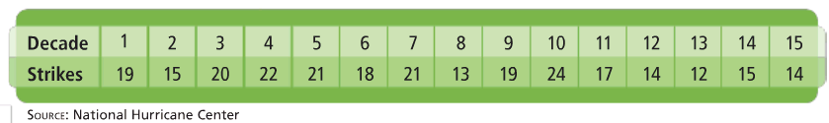

- What are the mean and the standard deviation for this data set?

- Within how many standard deviations from the mean do all the values fall?

You Try! Find the mean, standard deviation, and variance of the following data values. Within how many standard deviations of the mean do all the data values fall: 12, 17, 15, 13, 9, 10, 12, 10, 15, and 17?

EOC Prep: Answer the following End-of-Course question regarding standard deviation.
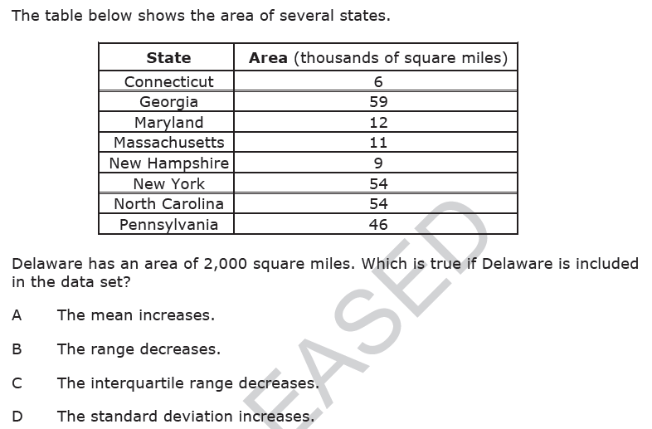

Math 1 4.2 Normal Distribution Unit 4

Normal Distribution: Data that vary randomly from the mean in a pattern of a _______________________________.
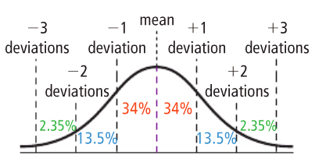
In a normal distribution:

- 68% of data fall within one standard deviation of the mean
- 95% of data fall within two standard deviation of the mean
- 99.7% of data fall within three standard deviations of the mean

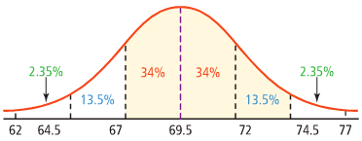
Example 1: The following normal distribution describes the repair times for a local auto shop. Answer the questions below:

48 66 84 102 120 138 156

- What is the mean repair time for the auto shop? What is the standard deviation?
- What percentage of car repairs take between 84 and 120 minutes?
- What percentage of the repairs take less than 2 hours?
- What percentage of car repairs are between 84 minutes and 138 minutes?

- If the shop did 200 repairs this week, approximately how many of them took more than 2 hours?

- If the shop did 300 repairs this week, approximately how many of them took less than 84 minutes?

Example 2: Sketch a normal curve for the following distribution: mean = 45, standard deviation = 5

You try! Sketch a normal curve for the following distribution: mean = 60, standard deviation = 15

