AFM 4.2 Function Notation Chapter 4

Lesson Vocabulary
Relation: A set of _____________ ____________. It can be written as ______________, _______________, or a _____________.
Domain: The set of _______ values in an ordered pair.
Range: The set of _______ values in an ordered pair.
Function: A relation in which every x value has only one y value. The X’s can’t ________________!!!!!
Vertical Line Test: A way to test if a graph is a function or not.
Function Notation: To write a rule in function notation, you use the symbol ________ instead of _____. It is read “F of X”

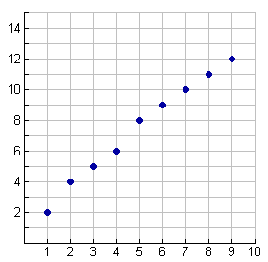
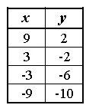
Identifying Domain and Range
List the domain and range for each relation.

- (4, 0) (2, 8) (6, -1) (10, 4)

Identifying Functions Using the Vertical Line Test
Drop a straight line through the graph. If it touches it twice, it is not a function!

Evaluating a Function
Step 1: Substitute the number inside f( ) into the equation for x.
Step 2: Simplify the equation.
Step 3: Rewrite as a solution set.

Evaluate each of the following.

- f(x) = 3x + 4 for f(2)
- f(x) = 3x² + 4 for f(6)
- f(x) = -12x + 1 for f(-3)

Evaluate each of the following.

- f(x) = 3x + 4 for f(x + 1)
- f(x) = 4(x + 2) for (3x)
- f(x) = -(x + 3) for (x² + 2)

Evaluating a Function with a Given Graph
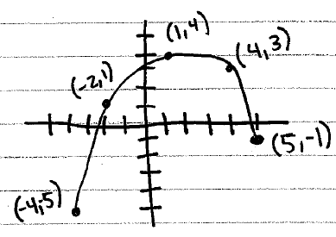
Domain:

Range:

Using the graph from above, find the following:

- f(-2)
- f(5)

- f(4) – 8
- f(4)•f(1)

