Math 3 4.2 Dividing Polynomials Unit 4

*EQ: How can we divide polynomials using long and synthetic division?*

There are two methods to use when dividing polynomials. The first is ***long division*.** Recall long division of integers and apply the same principals when dividing polynomials!

|  |  |
| --- | --- |
| Integer Long Division: | Polynomial Long Division: |
| $1234 ÷7$ |  |

**Note:** You can use polynomial long division to divide a polynomial of ***any*** degree.

**Example 1:** Divide 

**You Try!** Divide 

The second method of dividing polynomials is called ***synthetic division*.** Synthetic Division can only be used when the divisor is linear with a leading coefficient of 1.

*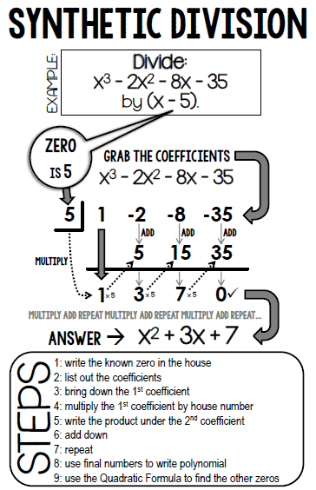Note: Continue to walk your exponents down. Fill in all missing terms with a zero.*

**Example 1:**Divide 

**Example 2:** Divide 

1. Write the known zero in the box

2. List out the coefficients

3. Bring down the 1st coefficient

4. Multiply the 1st coefficient by the box

number

5. Write the product under the 2nd coefficient

6. Add down

7. Repeat

8. Use the final numbers to write polynomial

**You Try!** Divide 

**You Try!** Divide 